

MASTER OF DATA SCIENCE (SEMESTER 2 – 2022/2023)

FACULTY OF COMPUTER SCIENCE & INFORMATION TECHNOLOGY

WQD7005 DATA MINING

GROUP ASSIGNMENT

**Title: Credit Card Customers - Predicting Customer Churn**

**Instructor: Prof. Dr. Loh Yuen Peng**

| **Group Members** | **Student ID** |
| --- | --- |
| Nicholas Tan Yu Zhe | S2180436 |
| Yap Jia Xian | S2150857 |
| Touhid Ahmed Choudhury | S2150778 |
| Nasir Uddin Ahmed | S2015449 |

**Table of Contents**

**1. Introduction 4**

**2. Dataset 5**

2.1 Dataset Information 5

2.2 Column Metadata 5

**3. Business Understanding 7**

3.1 Analysis Goal 7

3.2 Analysis Data 7

**4. Methodology 8**

**5. Results 9**

5.1 Sample - Accessing and Assaying 9

5.1.1 Metadata 11

5.1.2 Reclassification of the Role of the Variables 12

5.2 Explore - Exploring Data Source 13

5.2.1 Summary Statistics 13

5.2.2 Univariate Analysis 15

5.2.3 Bivariate Analysis 25

5.2.4 Multivariate Analysis 28

5.3 Modify - Data Modification 30

5.3.1 Modifying and Correcting Source Data 30

5.3.2 Examine Exported Data 37

5.3.3 Creating Training and Validation Data 39

5.4 Model - Data Modelling 40

5.4.1 Constructing a Decision Tree Predictive Model 40

5.4.2 Constructing a Gradient Boosting Predictive Model 41

5.4.3 Constructing a Logistic Regression Predictive Model 42

5.4.4 Constructing a Neural Network Predictive Model 43

5.5 Assess - Data Assessment 44

**6. Conclusion 44**

**7. Appendix 45**

5.1 Sample 45

5.2 Explore 60

5.3 Modify 67

5.3.1 Modify Dataset in Talend 67

5.3.2 Modify Dataset in SAS Miner 67

5.3.3 Data Partition 68

5.4 Model 68

5.4.1 Decision Tree Predictive Model 68

5.4.2 Gradient Boosting Predictive Model 70

5.4.3 Logistic Regression Predictive Model 72

5.4.4 Neural Network Predictive Model 74

5.5 Assess 76

# 

# Introduction

Customer churn is a serious issue for businesses, especially financial service providers like banks. Customers leaving a bank can have a detrimental effect on the earnings and reputation of the business. Therefore, in order for banks to continue to be profitable and develop, forecasting client attrition is essential.

Data mining techniques can be used to create precise predictive models that can identify the consumers that are most likely to churn in order to solve this problem. Data mining techniques can be used to create a predictive model that can identify consumers that are likely to churn using the Credit Card Consumers dataset, which is available on Kaggle.

As part of this project, we will examine the Credit Card Customers dataset and create a model that forecasts customer attrition. Data from the collection includes demographic and behavioral details about bank customers and their credit card usage habits. This project's goal is to use data mining techniques on the dataset, clean and prepare the data, find the pertinent features, and create a model that can precisely predict customer churn.

To be more precise, we will start by examining the dataset to better understand it and find any issues with data quality that need to be fixed. To find any patterns or trends in the data that might be helpful in predicting customer attrition, we will then do exploratory data analysis. The data will subsequently undergo preprocessing and cleaning to guarantee its consistency and quality. Then, using feature selection approaches, we will decide which features are most crucial for predicting customer attrition. Finally, using machine learning methods, we will create a predictive model and assess its effectiveness with the use of suitable metrics.

The project's findings can assist banks and other financial service providers in taking proactive steps to keep clients and sustain profitability. Therefore, we aim to use SAS Enterprise Miner software to understand the nature of data via visualization and inspect patterns via machine learning techniques.

# Dataset

In this section, we will discuss the dataset that we will be using for the rest of the assignment. The dataset is a collection of data that has been collected for a specific purpose.

## 2.1 Dataset Information

The Credit Card Customers dataset is a useful resource for researchers and practitioners in the field of data mining and machine learning. The dataset provides information about 10,000 bank customers and their credit card usage behavior, including demographic and behavioral characteristics. Overall, the Credit Card Customers dataset is a valuable resource for developing predictive models to identify customers who are likely to churn.

*Table 2.1: Dataset Information*

| **Property** | **Value** |
| --- | --- |
| Data Source | <https://www.kaggle.com/datasets/sakshigoyal7/credit-card-customers?resource=download> |
| Data Name | Credit Card Customers |
| Data Size | 1.44 MB |
| Year | 2020 |
| Dimension | 10,000 Rows and 23 Columns |

## 2.2 Column Metadata

Metadata is essential for making data accessible, interpretable, and reusable. It serves as a guide for anyone who wants to work with the data, enabling them to understand the variables and their relationships and make informed decisions about how to use the data effectively.

*Table 2.2: Metadata*

| **Attribute** | **Category** | **Description** |
| --- | --- | --- |
| CLIENTNUM | Integer | A unique identifier for each customer. |
| Attrition_Flag | String | A binary variable indicating whether the customer has churned or not (i.e., whether they have closed their credit card account). |
| Customer_Age | Integer | The age of the customer in years. |
| Gender | String | The gender of the customer (Male/Female). |
| Dependent_count | Integer | The number of dependents the customer has (e.g., children or elderly family members). |
| Education_Level | String | The highest level of education attained by the customer (e.g., high school, college, graduate). |
| Marital_Status | String | The marital status of the customer (Married, Single, Divorced, Unknown). |
| Income_Category | String | The annual income of the customer (e.g., Less than $40K, $40K - $60K, $60K - $80K, $80K - $120K, $120K +). |
| Card_Category | String | The type of credit card held by the customer (Blue, Silver, Gold, Platinum). |
| Months_on_book | Integer | The number of months the customer has been a credit card holder. |
| Total_Relationship_Count | Integer | The total number of products held by the customer with the bank (e.g., credit card, mortgage, checking account). |
| Months_Inactive_12_mon | Integer | The number of months in the past 12 months that the customer has not used their credit card. |
| Contacts_Count_12_mon | Integer | The number of times the customer has been contacted by the bank in the past 12 months. |
| Credit_Limit | Float | The credit limit is assigned to the customer. |
| Total_Revolving_Bal | Integer | The total amount of revolving credit the customer has (i.e., the portion of credit card spending that is not paid off each month). |
| Avg_Open_To_Buy | Float | The average amount of credit available to the customer (i.e., credit limit minus total revolving balance). |
| Total_Amt_Chng_Q4_Q1 | Float | The change in transaction amount (Q4 over Q1) for the past year. |
| Total_Trans_Amt | Integer | The total dollar amount of transactions made by the customer in the past year. |
| Total_Trans_Ct | Integer | The total number of transactions made by the customer in the past year. |
| Total_Ct_Chng_Q4_Q1 | Float | The change in transaction count (Q4 over Q1) for the past year. |
| Avg_Utilization_Ratio | Float | The average ratio of credit card spending to credit limit. |

# Business Understanding

In this section of the data mining assignment, we will delve into the business understanding of data mining. The company in question offers financial services, especially banks, and has a high rate of customer churn. Customer turnover is a serious issue for the business because it has a negative impact on both its revenue and reputation. The bank must precisely estimate client attrition in order to preserve profitability and expansion. However, given the intricacy of consumer behavior and the dataset's class imbalance, predicting churn is difficult.

## 3.1 Analysis Goal

This is a data mining project because it involves extracting knowledge from large amounts of data. The data in this case is a dataset of credit card customers, which includes information about their demographics, spending habits, and other factors. This data will be used to train a machine-learning model that can predict whether a customer is likely to churn.

Creating a model that can reliably forecast client turnover is the aim of this project. Credit card firms can use this data to target their marketing campaigns and customer retention plans. A corporation might, for instance, provide a customer with a special deal or promotion if a model indicates that they are likely to leave in an effort to retain their business.

## 3.2 Analysis Data

The data used for this project was obtained from the Kaggle website. The dataset contains information about 10,000 credit card customers, including their demographics, spending habits, and other factors. The data is in a tabular format, with each row representing a different customer and each column representing a different feature. The target variable is the Attrition Flag column. This column indicates whether the customer has churned or not.

In the Analysis Data part of the Credit Card Customers project, several steps can be taken to preprocess and analyze the dataset to prepare it for building a predictive model.

| Sl. | Steps |
| --- | --- |
| 01 | Data Cleaning: The dataset was first examined for any missing values, duplicates, or outliers. There were no missing values in the dataset. However, there were some duplicates in the dataset that were removed. Outliers were also identified and removed from the dataset. After data cleaning, the dataset contained 10,000 unique customer records. |
| 02 | Exploratory Data Analysis: The dataset was then analyzed to identify the distribution, correlations, and statistical properties of the features. Some of the observations made during the exploratory data analysis include:   1. The majority of the customers were male (54%) and married (46%). 2. Customers with higher credit limits tend to have higher transaction amounts and higher monthly average balances. 3. Customers with a higher number of dependent family members tend to have lower credit limits. 4. The majority of customers have an education level of either graduate or high school. 5. The average customer has a credit limit of $5,000. 6. The average customer spends $1,000 per month on their credit card. 7. The average customer has a monthly average balance of $500. 8. The average customer has 2 dependent family members. 9. The majority of customers have an education level of either graduate (38%) or high school (29%). |
| 03 | Feature Selection: Feature selection techniques were used to identify the most relevant features that can help predict customer churn. The correlation matrix was used to identify the features that are highly correlated with customer churn. |

# Methodology

In this assignment, we are following the systematic methodology SEMMA that was developed by SAS institute inc. SEMMA stands for Sample, Explore, Modify, Model, and Asses. The table below demonstrates each step in our project based on SEMMA methodology.

*Table 4.1: SEMMA Methodology*

| **No** | **Step Name** | **Activity** |
| --- | --- | --- |
| 1 | Sample | In this step, we will create a project in SAS. Then we will import a sample of data that represents the population. After that, we will identify the role of each variable and its level. Lastly, we will save the data file in sas7bdat format. |
| 2 | Explore | In this step, we will explore features and their patterns using univariate, bivariate, and multivariate analysis. These analyses will be conducted using the plotting tools in SAS Enterprise Miner. We will use histograms and box plots to identify feature distribution. We used pie charts for categorical variables, also scatter plots to quantitively identify the correlation between variables. |
| 3 | Modify | In this step, we will check data quality by inspecting missing values and replacing them with suitable values. We will also check for other errors such as duplicates, inconsistent, or outlier data. |
| 4 | Model | In this step, we will build suitable models, using different machine learning algorithms. |
| 5 | Assess | In this step, we will assess the performance. |

# Results

## 5.1 Sample - Accessing and Assaying

In the first step in this methodology is called the "Sample" stage which is the first step of this methodology, which focuses on the collection and organization of the relevant data. The dataset for this project has been compiled and stored in CSV format. This datasets contains information on various effects that can influence a customer's decision to discontinue their credit card services. These factors include age, income, education, and other demographics. Before diving into the analysis, the CSV file will be converted to a SAS file, which will enable us to leverage the powerful statistical analysis capabilities of the SAS platform. This dataset consists of 23 variables and 10,127 records.

Description

1. A unique identifier for each customer. **(CLIENTNUM)**
2. A binary variable indicating whether the customer has churned or not **(Attrition_Flag)**
3. The age of the customer in years. **(Customer_Age)**
4. The gender of the customer **(Gender)**
5. The number of dependents the customer has **(Dependent_count)**
6. The highest level of education attained by the customer **(Education_Level)**
7. The marital status of the customer **(Marital_Status)**
8. The annual income of the customer **(Income_Category)**
9. The type of credit card held by the customer **(Card_Category)**
10. The number of months the customer has been a credit card holder. **(Months_on_book)**
11. The total number of products held by the customer with the bank **(Total_Relationship_Count)**
12. The number of months in the past 12 months that the customer has not used their credit card. **(Months_Inactive_12_mon)**
13. The number of times the customer has been contacted by the bank in the past 12 months. **(Contacts_Count_12_mon)**
14. The credit limit is assigned to the customer. **(Credit_Limit)**
15. The total amount of revolving credit the customer has **(Total_Revolving_Bal)**
16. The average amount of credit available to the customer **(Avg_Open_To_Buy)**
17. The change in transaction amount (Q4 over Q1) for the past year. **(Total_Amt_Chng_Q4_Q1)**
18. The total dollar amount of transactions made by the customer in the past year. **(Total_Trans_Amt)**
19. The total number of transactions made by the customer in the past year. **(Total_Trans_Ct)**
20. The change in transaction count (Q4 over Q1) for the past year. **(Total_Ct_Chng_Q4_Q1)**
21. The average ratio of credit card spending to credit limit. **(Avg_Utilization_Ratio)**

### 5.1.1 Metadata

In this section, we will examine the metadata of our dataset, which provides an overview of the column Role setting, variable types in Basic Setting(Figure 5.1) and Advance Setting(Figure 5.3), and attributes. Understanding the metadata is essential for accurate analysis, as it helps ensure that each variable is treated appropriately and the results are reliable.

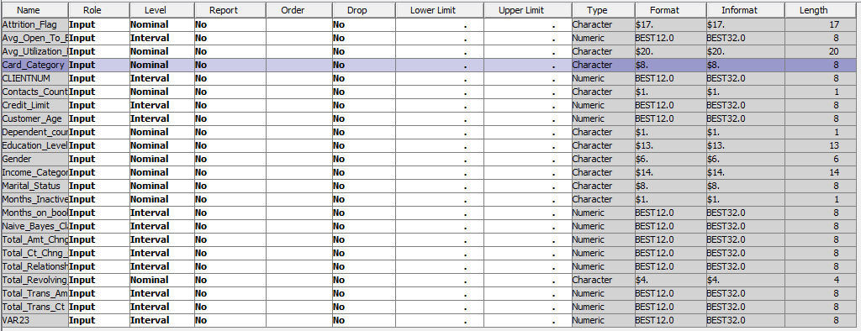

*Figure 5.1 Basic Setting Metadata*

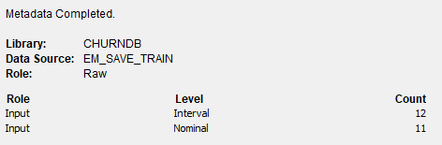

*Figure 5.2 Data Type Summary*

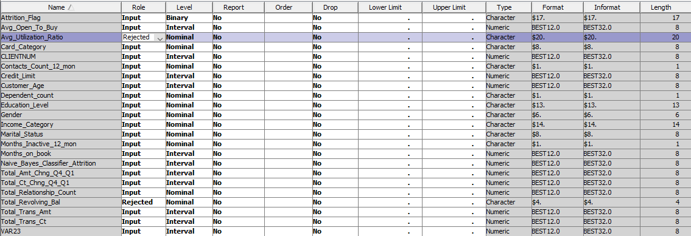

*Figure 5.3 Advanced Setting Metadata*

In the Basic Setting it means when you are already familiar with the variable roles and measurement levels. The initial role and level assignments depend on the variable type and format values. Advanced Setting is referred to if you prefer SAS Enterprise Miner to automatically determine the variable roles and measurement levels. This automatic assignment is based on the variable type, format, and the number of unique values present in the variable. in the role default setting there are few “Rejected” roles because of few reasons such as missing values, low variance, or the presence of unique identifiers. SAS enterprise miner automated variable selection process aims to optimize model performance by focusing on the most relevant and informative variables. But we will be doing data cleaning in the Modify stage so we will manually change the role back to the input role.

### 5.1.2 Reclassification of the Role of the Variables

Here we are doing reclassification of the role because we need a more suitable dataset in this project because SAS advanced setting still have some differences with our ideal role(Figure 5.4).

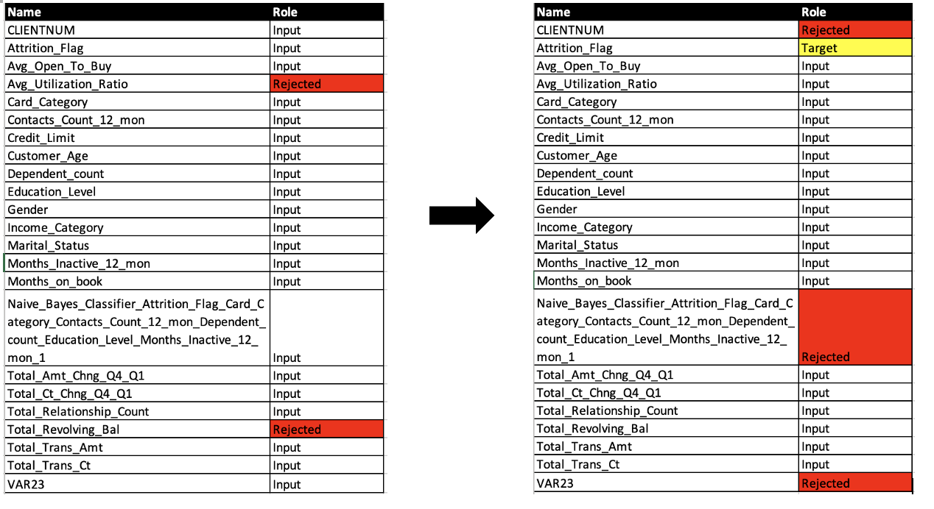

*Figure 5.4 Reclassification Column Role*

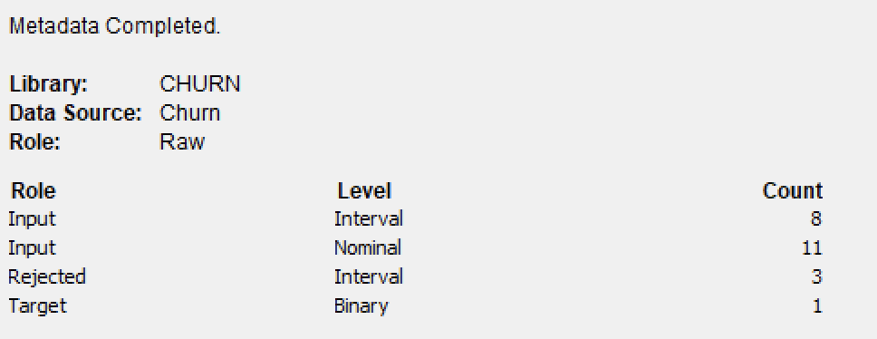

*Figure 5.5 Data Type Summary after Reclassification*

Based on the Figure 5.4 we change the column “Avg_Utilization_Ratio” and “Total_Revolving_Bal” from Rejected to Input and we rejected some we already identify the column is useless such as “CLIENTNUM” , “Naive_Bayes…” and “VAR23”. This column included client ID, NaiveBayes Results so is not related to this project. Lastly, we also changed “Attrition_Flag” role to target role which means this column is our target variable.

Not only that, we also notice some of the column Level is incorrect such as category should be nominal but it becomes interval but is not able to change now (SAS not allowed) because of the missing value or some symbol such as “-” in the dataset. To solve this issue we will change the level after we do the Modify which is the Data Cleaning Process.

## 5.2 Explore - Exploring Data Source

The Explore phase is the stage where the data is thoroughly investigated and analyzed to identify patterns, trends, anomalies, relationships, and any underlying structure that might exist within the data. This is a crucial step to gain insights and understanding of the data before moving on to the Modify phase.

### 5.2.1 Summary Statistics

In the summary statistics, it can define the measures of central tendency. The most common measures of central tendency are the mean, median, and mode. Not only that, the summary statistics in SAS enterprise miner also will be showing the Standard Deviation, Missing value and so on. Figure 5.6 will show the summary of statistics for interval variables and Figure 5.7 for class variables.

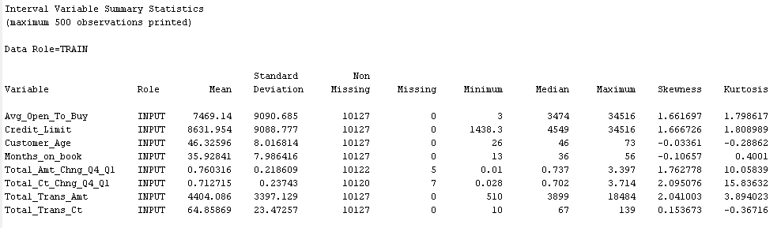

*Figure 5.6 Interval Variable Summary Statistics*

Figure 5.6 can get some information, there are some missing values in this dataset which is the “Total_Amt_Chng_04_Q1” and “Total_Amt_Chng_04_Q1”. Otherwise, there are no other abnormal values or other errors in the current stage and understanding.

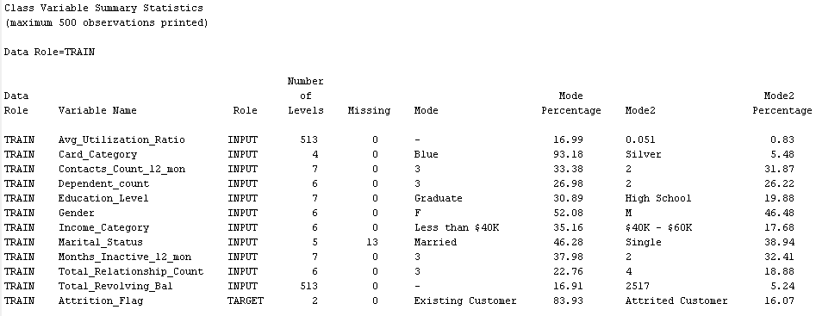

*Figure 5.7 Class Variable Summary Statistics*

In Figure 5.7 , there are some interval variables in the nominal variable such as “Total_Revolving_Bal” and “Avg_Utilization_Ratio” that should be in the interval role. But there are some abnormalities such as some rows are “-” . Based on our study we can assume “-” is 0 in this dataset , In the SAS enterprise miner it is considered as character means in the current it is not allowed to change to nominal and have to do it after the Modify stage.

Moreover, “Marital_Status” has 13 missing rows. In the “Gender” there are 6 levels of gender which means there is some inconsistent data in these columns. In the visualization stage can figure out whether other columns are having the same issues. For the target variable which is “Attrition_Flag” the mode percentage of the Existing Customer is 83.93 which means this dataset is highly biassed.

### 5.2.2 Univariate Analysis

Univariate analysis in data mining refers to the examination of a single variable or attribute at a time. It aims to summarize and describe the main features of the data, such as central tendency, dispersion, and distribution shape. Univariate analysis is the simplest form of data analysis and serves as a foundation for understanding the characteristics of individual variables before diving into more complex multivariate analysis techniques.

In Table 5.1 summarising all the interval variables in the histogram format it will provide us the analysis, distribution shape or any abnormal data or bin.

*Table 5.1 Histogram’s Findings*

| **No.** | **Variable** | **Findings** |
| --- | --- | --- |
| 1. | **Avg_Open_To_buy** | * Most of the client Average Open to buy is from 14 to 6914.4 * No missing value in this Column |
| 2. | **Credit_Limit** | * Same as Avg_Open_To_Buy which means the client open to buy amount is used to decide the credit limit. |
| 3. | **Customer_Age** | * Symmetric Skewed Distribution * No missing Values * Most Customer Age range is between 35-54 |
| 4. | **Months_on_book** | * Symmetric Skewed Distribution * Most of the values focus on 30.2 to 38.8. * No missing values * Outlier detected |
| 5. | **Total_Amt_Chng_Q4_Q1** | * Most of the value is focus on 0.153 to 1 * Outlier Detected * Missing Values Detected |
| 6. | **Total_Ct_Chng_Q4_Q1** | * Same as Total_Amt_Chng Column * Missing Values Detected |
| 7. | **Total_Relationship_Count** | * Wrong variable type in SAS should be in Nominal Type not Interval. |
| 8. | **Total_Trans_Amt** | * Right Skewed Distribution * Usually the client transaction amount is 1000 to 2500 in this range. There are low client transaction amounts of less than 3000. |
| 9. | **Total_Trans_Ct** | * Right Skewed Distribution * In the Last 12 months, most of the clients will be doing transactions in the range between 18-50 per year. * No Missing Values. |

*Table 5.2 Box Plot Findings*

| **No.** | **Variable** |
| --- | --- |
|  | **Customer_Age & Months_on_book**    Findings   * Based on these two features, the Customer_Age and Months_on_book can justify these two features without any outlier or abnormal row by using IQR approach. |
| 2.. | **Credit_Limit, Avg_Open_To_Buy, Total_Amt_Chng_Q4_Q1, Total_Trans_Amt, Total_Trans_Ct, Total_Ct_Chng_Q4_Q1**    Findings   * Outlier is detected on all these features. * But it does not mean all this data is considered outlier, it needs to have more justification .Outliers can occur due to various reasons such as measurement errors, data entry errors, or genuine extreme values. * It is important to investigate the reason for the outlier and decide whether it should be removed or retained in the dataset based on the analysis objectives and the nature of the data. |

Pie charts are a type of graph used in univariate analysis to display the distribution of a categorical variable. Pie charts are useful for quickly visualizing the proportion of each category in a dataset, and can be easily understood by non-expert audiences. When using pie charts in univariate analysis, it is important to choose an appropriate number of categories to display and to ensure that the categories are mutually exclusive and collectively exhaustive.

*Table 5.3 Pie Chart Findings*

| **No.** | **Variable** |
| --- | --- |
|  | Findings:   * All these data are in the correct role but there are still some of the features that have some missing value such as ‘-’. * In the Card_Category pie chart not only blue and others. The others are included gold and silver but the blue occupied the majority so others will become “Others” |
| 2 | **Incorrect Pie Chart**    Findings   * These two pie charts are incorrect. Pie Chart should be for Nominal not for interval variable. * Need to modify the role after the modify process is done. |

*Table 5.4 Bar Chart Findings*

| **No.** | **Variable** | **Findings** |
| --- | --- | --- |
| 1. | **Attrition_Flag** | * This column is clean. * Data imbalance. Can justify existing customers having more than attrited customers in a huge number. |
| 2. | **Card_Category** | * Most of the customer majority is in the blue category with only a very small number of customers holding Gold, Silver and Platinum. * No missing value. |
| 3. | **Contacts_Count_12_mon** | * Most of the Customers got contacted in the last 12 months 3 and 2 times. * “-” in this dataset will be assumed in 0. |
| 4. | **Dependent_count** | * Most of the Customers having dependents count that in the range 1-4. * Only a few customers have 0 and 5. There is no more data than 5. * “-” in this dataset will be assumed in 0. |
| 5. | **Education_level** | * Most of the customers have at least “Graduate” education level. * Only 175 customers having the Post-Graduate education level and above. |
| 6. | **Gender** | * Having Inconsistent data in this variable * Male and Boy should be in the “M” category * Female and Girl should be in the “F” category |
| 7. | **Income_Category** | * The highest category in income category is Less than $40k accordingly, $80k-60k * In application credit card income must be compulsory so we can know that Unknown is Noisy Data. |
| 8. | **Marital_Status** | * Missing Value in the blank category * It should be in Unknown Category * Can justify most of the card holders being married. |

### 5.2.3 Bivariate Analysis

Bivariate Analysis is used to analyze the relationship between two variables. There are multiple plots that can be used for bivariate analysis, such as Bar plot, Scatter plot, and Box plot. The findings of the bivariate analysis are shown in Table 5.5.

*Table 5.5: Bivariate Analysis Findings*

| **No.** | **Variable** | **Findings** |
| --- | --- | --- |
| 1 | **Attrition Flag vs Gender** | * The attrition of male customers is similar to female customers, even though the total existing customer for male is higher than female. * The number of other gender types is low as compared to the M and F. |
| 2 | **Attrition Flag vs Customer Age** | * The median of attrited customers is higher (50) as compared to existing customers (46). * However, the maximum whisker for existing customers is higher than attrited customers when the third quantile for attrited customers is higher than existing customers. |
| 3 | **Attrition Flag vs Months on Book** | * There is a massive spike at month 36, it could be that the majority of the customers from this dataset are very recent due to some campaign or it is a data input issue. * The remaining months are relatively normal. |
| 4 | **Attrition Flag vs Income Category** | * The attrited customers and existing customers are exhibiting the same pattern, which means that income does not affect on customer attriting. * The income category of less than $40k is having the most number of customers. |
| 5 | **Marital Status vs Income Category** | * There is no significant difference between attrited customers and existing customers. |
| 6 | **Income Category vs Education Level** | * The overall pattern for all different education levels is similar. * The highest number of customers is the Graduate education level. |
| 7 | **Customer Age vs Total Transaction Amount** | * It can be observed that around age 40 to 55 there is a slight dip in terms of total transaction amount. * The customer with age below 40 is having a higher total transaction amount. |
| 8 | **Credit Limit vs Income Category** | * The credit limit across all income categories is normal as lower income would have lower credit limit. * However, there are some outliers across different income categories. |
| 9 | **Total Transaction Amount vs Income Category** | * Surprisingly, the total transaction amount is extremely similar across different income categories. |
| 10 | **Credit Limit vs Total Transaction Amount** | * It can be observed that the majority of customers are having lower credit limits. * However, the total transaction amount is much higher at lower credit limit range as compared to higher credit limit |

### 5.2.4 Multivariate Analysis

Multivariate analysis is similar to bivariate analysis, except it consists of more than two variables to be analyzed. Different types of charts can be used for multivariate analysis such as Scatter plot and Bar plot. The results are shown in Table 5.6.

*Table 5.6: Multivariate Analysis Findings*

| **No.** | **Variable** | **Findings** |
| --- | --- | --- |
| 1 | **Attrition Flag vs Credit Limit vs Total Transaction Amount** | * The chart is showing credit limit vs total transaction amount and is separated by the attrition flag by different colors. * It can observed that most of the attrited customers are from the lower range of both credit limit and total transaction amount. |
| 2 | **Attrition Flag vs Credit Limit vs Customer Age** | * The chart is showing credit limit vs customer age and is separated by the attrition flag by different colors. * It can be observed that there is no significant pattern for attrited customers vs existing customers in terms of credit limit and customer age. |
| 3 | **Attrition Flag vs Total Transaction Amount vs Total Transaction Count** | * The chart is showing the total transaction amount vs total transaction count and separated by the attrition flag by different colors. * It can be observed that there is a significant pattern, in which the attrited customer is having lower number of transaction count and amount as compared with existing customers. |

Other than that, correlation matrix and Cramer's V statistics can also be used for multivariate analysis. For numerical variables, correlation matrix will be used, and Cramer’s V statistics will be used for categorical variables. For correlation matrix, it is a plot of two different colors such as red and blue which corresponds to -1 to 1. The strength of the correlation is quantified by using different hues, with the darker the hue, the stronger the correlation. For Cramer’s V statistics, it is used to calculate the association between the categorical variables and target variable (Attrition Flag), and is measured between 0 to 1, where 0 corresponds to no association between target variable and the measured variable, and 1 corresponds to perfect association. A coefficient of 0.1 indicates that there is an association between the two variables used as a threshold in this report.

For numerical variables, correlation matrix is used, and the result is shown in Figure 5.8. From Figure y, Credit_Limit is having correlation coefficient of more than 0.8, which is 0.99, which will be dropped in the next stage. Customer_Age is also having a high correlation of 0.78, but is below the threshold of 0.8, which will not be dropped.

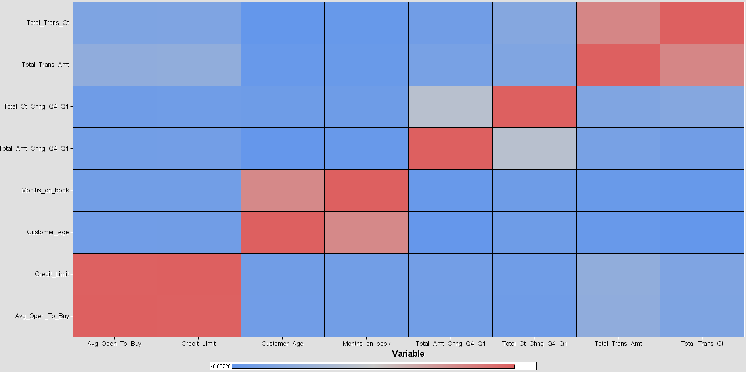

*Figure 5.8: Correlation Matrix for Numerical Variables*

Cramer’s V statistics is used for categorical variables and the results are shown in Figure 5.9. From Figure X, none of the variables are having perfect association with the Attrition Flag. Using the threshold of 0.1, Total_Revolving_Bal, Avg_Utilization_Ratio, Contacts_Count_12_mon, Months_Inactive_12_mon, and Total_Relationship_Count is showing association towards Attrition Flag.

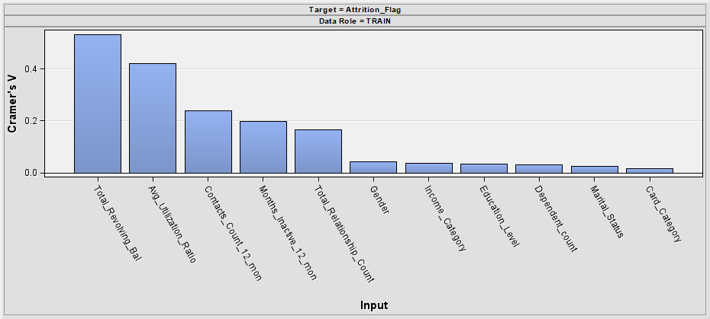

*Figure 5.9: The Cramer’s V Statistics Result as Compared with Attrition Flag*

## 5.3 Modify - Data Modification

### 5.3.1 Modifying and Correcting Source Data

The Modification stage is the third step in the SEMMA technique. The necessity of ensuring that the data we use to create the mining model is consistent, accurate, and dependable gives this stage its significance. Without changing the dataset, the data may be contradictory, inaccurate, or entirely incorrect, which results in erroneous inferences and decisions.

We accomplish the following objectives by cleaning the dataset;

**Spend Less Time and Money**: As the likelihood of receiving inaccurate results after data cleansing is reduced.

**Boost Data Quality**: Because data cleansing improves the completeness, consistency, and reliability of data.

**Enhancement Decision Making Process**: The quality of conclusions relies heavily on the quality of the used data, and data cleaning improves the quality of it.

We discovered a few mistakes in the explore section of the previous chapter, including incomplete, inconsistent, and noisy data. These data errors were discovered:

*Table 5.7: Error Types*

| **Variable** | **Error Type** |
| --- | --- |
| Marital Status | Incomplete |
| Income Category | Noisy |
| Total_Revolving_Bal, Total_Amt_Chng_Q4_Q1  Dependent_count, Months_Inactive_12_mon, Gender,  Contacts_Count_12_mon, Avg_Utilization_Ratio | Inconsistent |

Talend will be used to resolve each of these faults. Talend is an open-source data integration platform that provides a variety of tools and services for jobs including data management, cloud storage, big data, and business application connection. As we investigated the data, we discovered:

*Table 5.8: Talend Data Preparation*

| **Image & Variable** | **Explanation** |
| --- | --- |
|  | Marital_Status  - Here we doing imputation the empty row  - For this column is Nominal, So the imputation method will be using Mode.  - In Talend will using the function to fill the empty cells with the text 'Married' |
|  | Income_Category  - For income category we need to remove the row that indicate 'Unknown'  - It is unusual that a Bank churn dataset having an Unknown row in the income_category. |
|  | Total_Revolving_Bal, Total_Amt_Chng_Q4_Q1, Dependent_count, Months_Inactive_12_mon  Contacts_Count_12_mon,  Avg_Utilization_Ratio  - All these columns that contain '-' are the reason why in the previous chapter (Explore) we are not able to change the data type.  - After our observation, we found that the - actually is meaning 0 so we impute all the '-' to 0. |
|  | Gender  - In the explore part, we figure that gender column contains such as 'Male', 'Female', 'Boys' and 'Girl'  - We impute all of these into 'M' stand for Male and 'F' stand for Female |

Moreover, Data normalization is essential in this project because it ensures that our data is accurate, reliable, and easy to work with. When we normalize data, we bring it into a consistent and standardized format. This means removing any redundancies and anomalies, so that our data is clean and consistent across different datasets. By doing this, we improve the integrity of our data and make it easier to compare and analyze information.

*Table 5.9: Transformation of Data*

| **Before Transformation** | **After Transformation** |
| --- | --- |
|  |  |
|  |  |
|  |  |
|  |  |
|  |  |
|  |  |
|  |  |
|  |  |
|  |  |
|  |  |

### 5.3.2 Examine Exported Data

In the previous we found there are few column in the wrong data type: we have been change the data type to below:

*Table 5.10: Change of Data Type*

| **Column** | **Data Type** |
| --- | --- |
| Total_revolving_bal  Avg_Utilization_Ratio | Nominal to Interval |
| Total_Relationship_Count  Dependent_count | Interval to nominal |

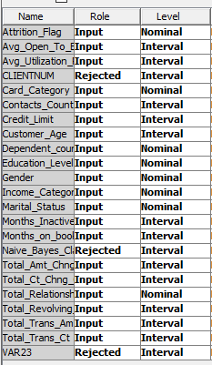

*Figure 5.10: Change of Data Type in SAS Workspace*

Next we also remove and impute the missing for example can show the missing bin has become blank/zero after modifying the data.

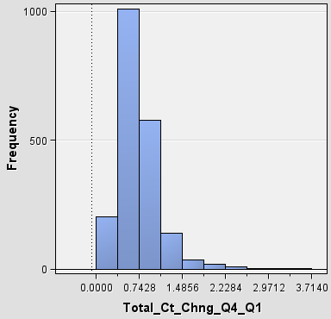

*Figure 5.11: Modification*

Furthermore, after our observation we know all of the ‘-’ meaning 0 in this dataset so we impute ‘-’ to become 0.Not only that, we also impute all inconsistent data in gender to the correct category. Such as :-

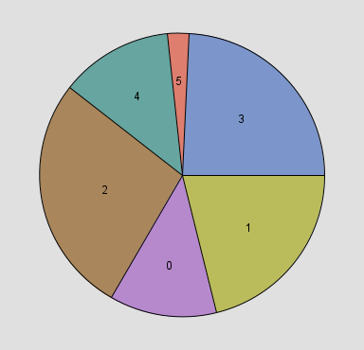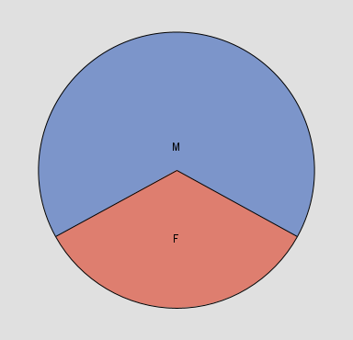

*Figure 5.12: Imputation*

We observed there are outliers in this dataset. However, the decision was made not to remove these outliers as they still fall within the range of reasonable values in reality. It is important to consider that outliers can arise due to various factors such as measurement errors or rare occurrences, which should not necessarily be discarded from the dataset. By retaining these outliers, the aim is to ensure that the data processing accurately reflects the true nature of the data, encompassing the full spectrum of observations, including those that deviate from the norm.

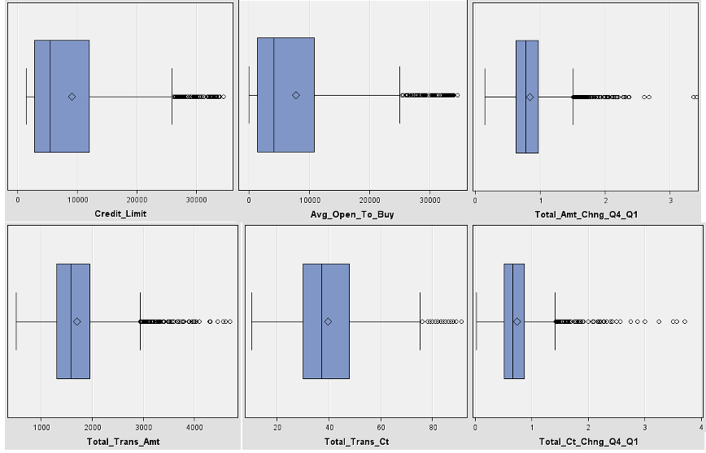

*Figure 5.13: Boxplot to Show Outliers*

### 5.3.3 Creating Training and Validation Data

The modified dataset is exported from Talend Data Preparation and imported into SAS Enterprise Miner. We used the data partition node to split the data randomly to 50% training and 50% validation.

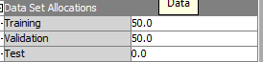

*Figure 5.14: Dataset Allocations*

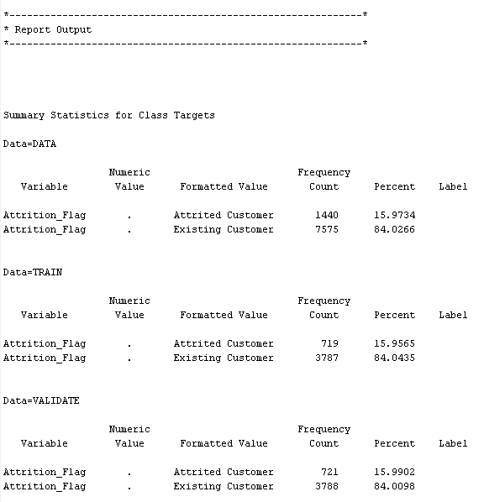

*Figure 5.15: Data Partition Node Report*

We will drop all of the unused data column which is ‘CLIENTNUM’ and previous naive bayes classification results.

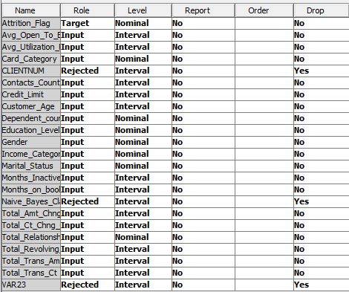

*Figure 5.16: Dropping Variables*

## 5.4 Model - Data Modelling

Several predictive models are constructed utilizing the training dataset and the train and validation dataset gained from the previous section. Four different prediction models, including Decision Tree, Gradient Boosting, Logistic Regression, and Neural Network, will be utilised to predict customer attrition in this part.

### 5.4.1 Constructing a Decision Tree Predictive Model

Decision tree is a tree-based supervised predictive model that consists of root node, internal node, branches, and leaf node. Each node in the decision tree corresponds to a decision rule that divides the targets in order to solve the classification task. Due to the simplicity of the model, decision tree is generally used in any projects. We developed the model with 2 branches maximum and a maximum depth of 6 so we can avoid overfitting.

The decision tree node will be used and the tree built is shown in Figure 5.17.

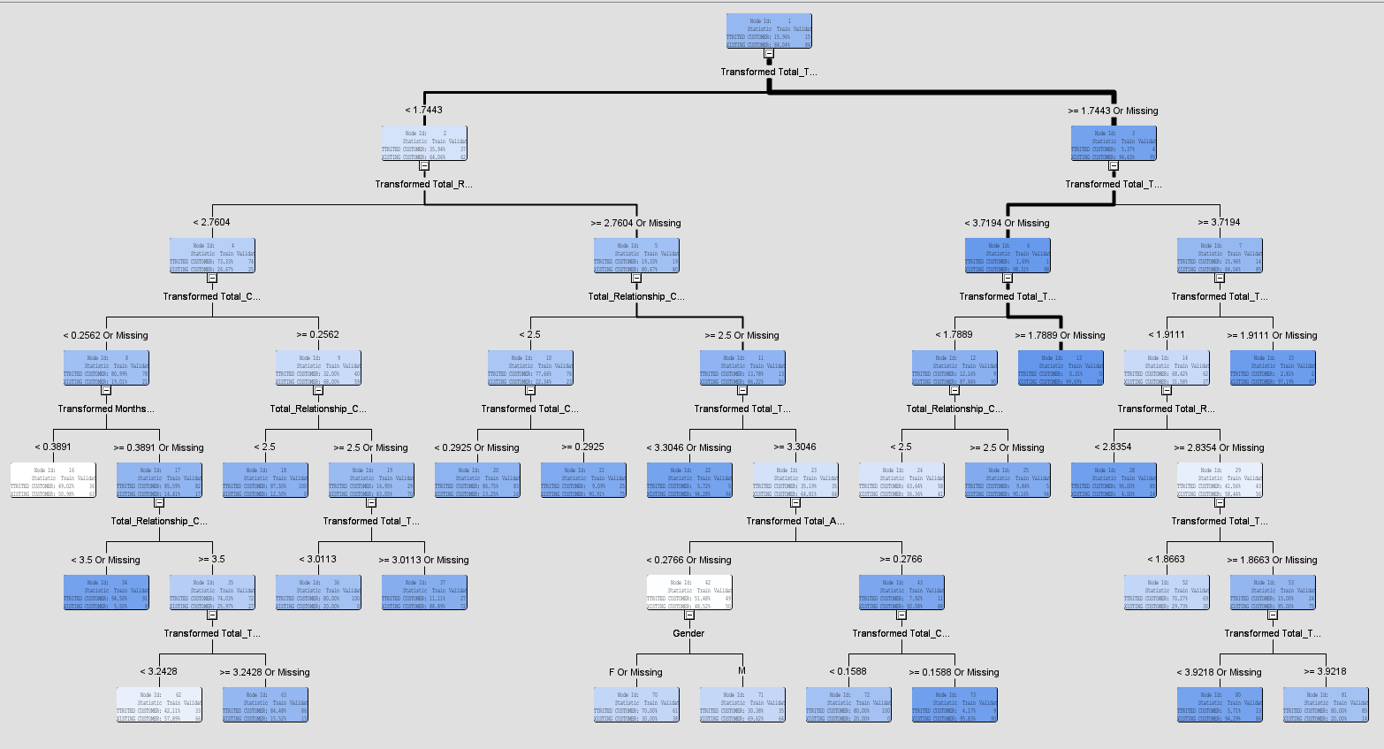

*Figure 5.17: Decision Tree*

From the decision tree shown in Figure 5.17, Total_Trans_Ct is selected as the root node as it is having the lowest entropy value which is able to effectively split the data. Other than that, the shortest split in order to achieve a conclusion is with 3 layers of rules and the longest split is 6 layers of rules. The statistical results obtained are shown in Figure 5.18. The misclassification rate of the decision tree predictive model achieved 0.063207.

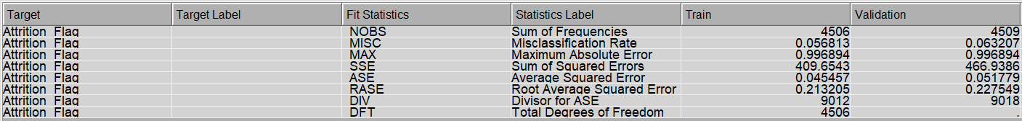

*Figure 5.18: The Statistical Result of Decision Tree Predictive Model*

Furthermore, the variable importance can be obtained from the decision tree and the output is shown in Figure 5.19. The top 5 variables that have the highest importance to customer attrition are Total Transaction Count, Total Revolving Balance, Total Relationship Count, Total Transaction Amount, and Total Change of Count in Quarter 4 to Quarter 1.

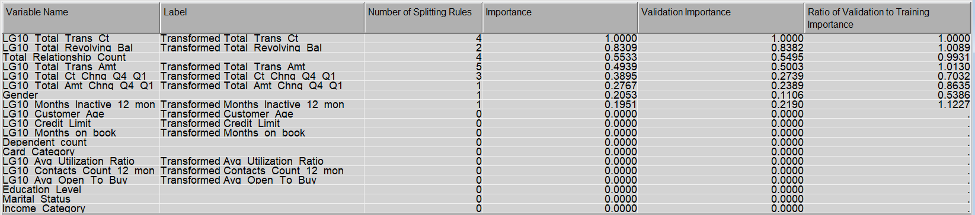

*Figure 5.19: Variable Importance from Decision Tree Predictive Model*

### 5.4.2 Constructing a Gradient Boosting Predictive Model

A gradient boosting model is an effective machine learning method that combines multiple weak prediction models, like decision trees, to create a robust and precise predictive model. It employs an iterative optimization process that gradually minimizes a loss function by adding new weak models to the ensemble. Each new model is trained to improve upon the mistakes made by the previous models, resulting in enhanced overall predictions. By iteratively refining the model based on the gradients of the loss function, gradient boosting models can capture intricate patterns in the data and deliver highly accurate predictions for both regression and classification tasks. As a result, they are widely utilized in various fields. The statistics of the Gradient Boosting model show that the misclassification rate is 0.066 which translate into an accuracy of 93.4%% as shown below.

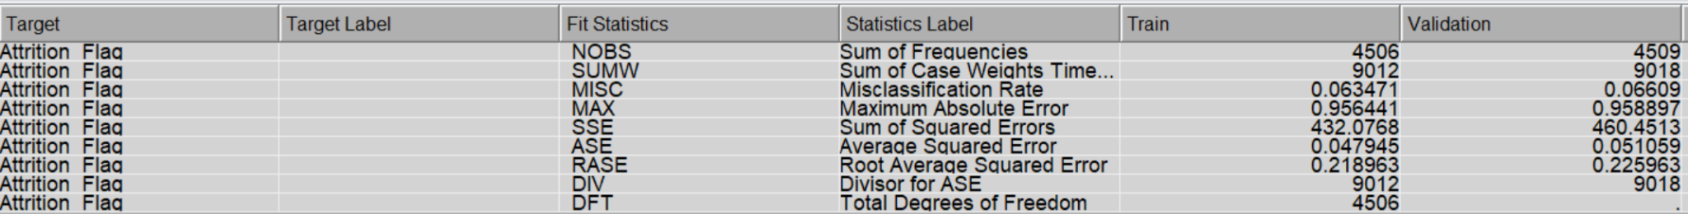

*Figure 5.20: The Statistical Result of Gradient Boosting Predictive Model*

The variable importance from Gradient Boosting Model are shown in Figure 5.X, and the top 5 variables are Total Transaction Amount, Total Transaction Count, Total Revolving Balance, Total Change of Count in Quarter 4 to Quarter 1, and Total Relationship Count.

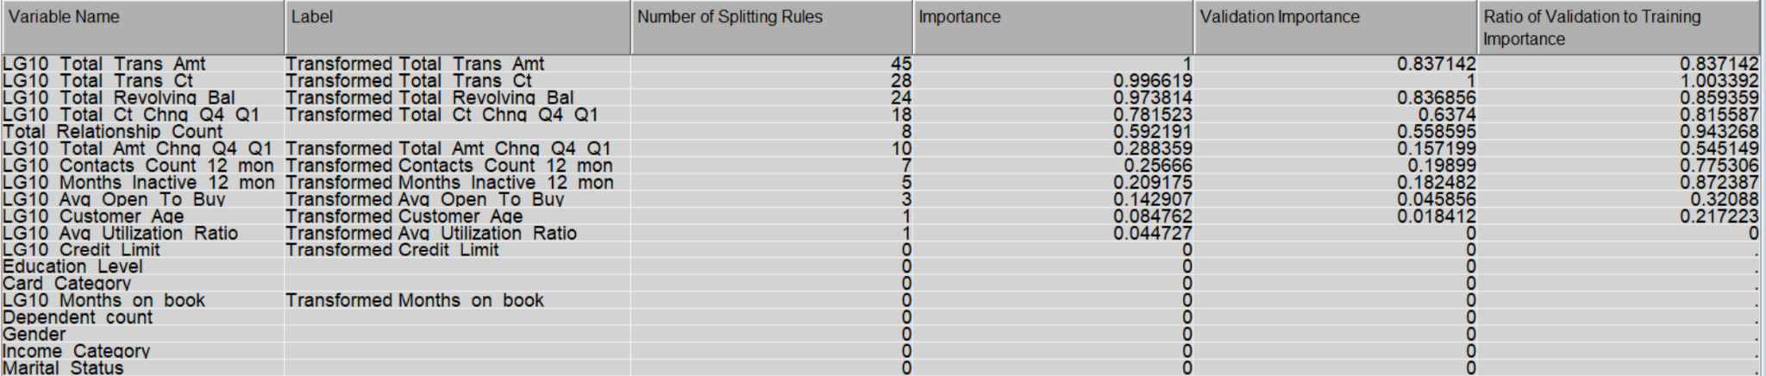

*Figure 5.21: The Variable Importance from Gradient Boosting Predictive Model*

### 5.4.3 Constructing a Logistic Regression Predictive Model

Logistic regression is a statistical modelling technique used for binary classification tasks, which predicts the probability of an event occurring based on input variables. It utilizes a logistic function to transform the linear combination of the input features into a probability value between 0 and 1. The model learns the relationship between the input variables and the binary outcome by estimating the coefficients that best fit the data. These coefficients indicate the impact of each input variable on the predicted probability. Logistic regression is widely used due to its simplicity, interpretability, and ability to handle large datasets. It is commonly employed in various fields, including healthcare, social sciences, and finance, for predicting outcomes such as disease presence, customer churn, or credit default.

The regression node is used and the statistical result is shown in Figure 5.22. The misclassification rate of the Logistic Regression predictive model achieved 0.096474.

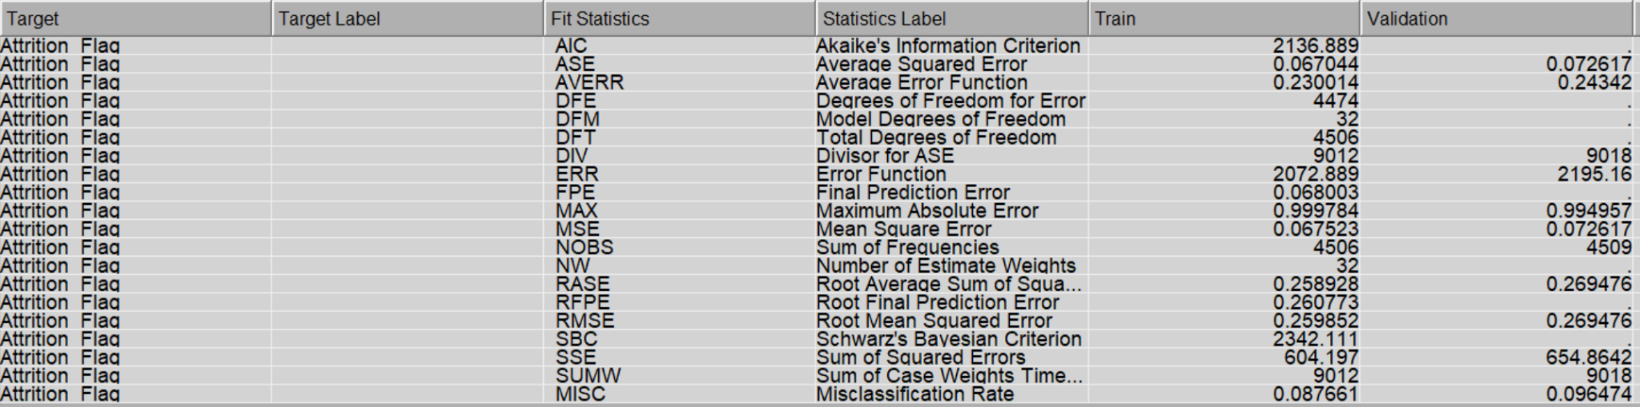

*Figure 5.22: The statistical result of Logistic Regression Predictive Model*

Odds ratio estimates in logistic regression quantify the relationship between independent variables and the probability of an event occurring. They represent the change in the odds of the event for each unit change in the independent variable, providing insights into the strength and direction of their associations. Total of three variables having 999 as the point estimate which is unable to be interpreted – Average Utilization Ratio, Total Change of Count in Quarter 4 to Quarter 1, and Total Transaction Count. From the result, it can be observed several things as shown below:

* Total Change of Amount in Quarter 4 to Quarter 1 is having 28 times the odds of having customer attrition than existing customers.
* Average Open to Buy is having 24 times the odds of having customer attrition than existing customers.

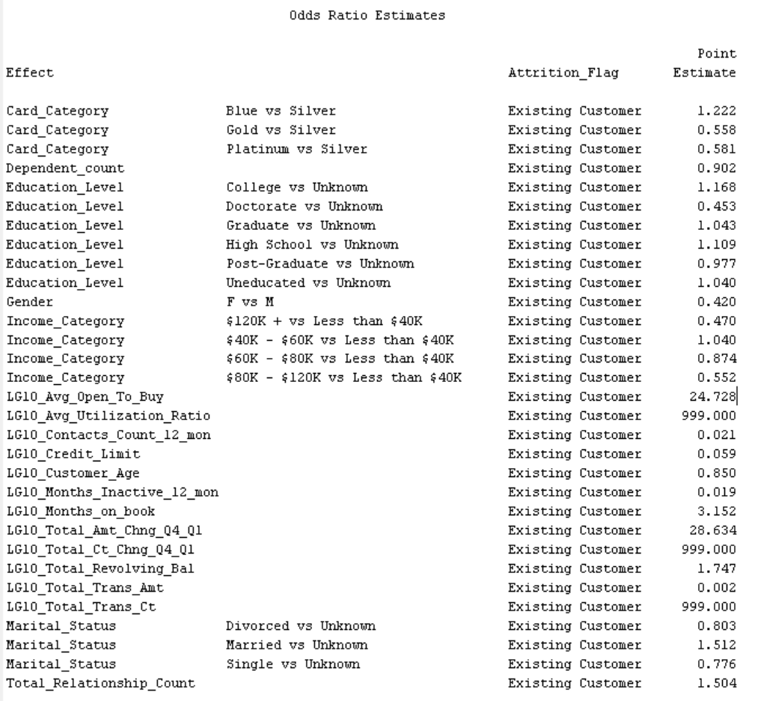

*Figure 5.23: The Odds Ratio Estimates for Logistic Regression Predictive Model*

### 5.4.4 Constructing a Neural Network Predictive Model

A neural network is a type of machine learning model inspired by the structure and functioning of biological neural networks. It consists of interconnected layers of artificial neurons that process and transmit information. Each neuron takes input from the previous layer, applies a mathematical operation to it, and produces an output. Through a process called training, neural networks learn to adjust the weights assigned to connections between neurons to optimize their performance on a given task, such as classification or regression. Neural networks are capable of capturing complex patterns and relationships in data, making them widely used in various fields, including image recognition, natural language processing, and predictive analytics.

The Neural Network node is used with the default value of 3 hidden layer and the statistical result is shown in Figure 5.24. The misclassification rate of the neural network predictive model achieved 0.075627.

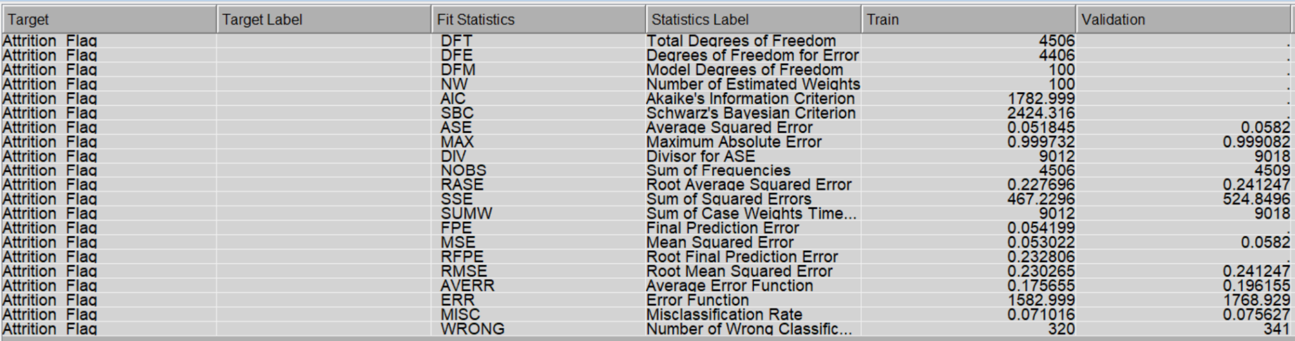

*Figure 5.24: The statistical result for Neural Network Predictive Model*

## 5.5 Assess - Data Assessment

The developed models are assessed in the Assess phase of SEMMA methodology. So, the Decision Tree, Gradient Boosting, Logistic Regression and Neural Network model nodes are connected to a control point node and control point node is connected to the Model Comparison node. The model comparison node is used to compare the performance of each model.

It can be observed that Decision Tree are being selected out of the four models built with the lowest misclassification rate of 0.063207, which can be interpreted as 93.6793% accuracy in predicting whether a customer will remain or attrite. The remaining accuracy obtained are 93.391%, 92.4373%, and 90.3526% which are Gradient Boosting, Neural Network, and Logistic Regression respectively.

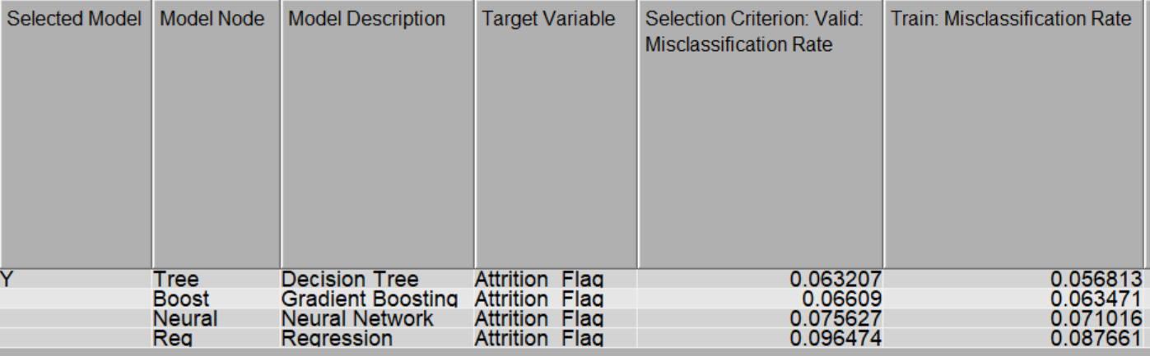

*Figure 5.25: The performance comparison across different predictive models*

# Conclusion

In this project, the Credit Card Customers Data collection was mined for useful insights using the SEMMA methodology. Sampling the data into SAS Enterprise Miner and storing it as a data source was how we began the mining process. Then, using univariate, bivariate, and correlation analysis visualization tools from the SAS software, we investigated the dataset's attributes. During the data examination, it was discovered that the data had purposeful, noisy, inconsistent, and incomplete flaws. After that, we modified the dataset from noisy data, i.e., we removed duplicated rows, imputed missing values.

| **Variable** | **Error Type** |
| --- | --- |
| Marital Status | Incomplete |
| Income Category | Noisy |
| Total_Revolving_Bal  Total_Amt_Chng_Q4_Q1  Dependent_count  Months_Inactive_12_mon  Gender  Contacts_Count_12_mon  Avg_Utilization_Ratio | Inconsistent |

It is found that the following variable are most relevant and other variables are rejected for the data modelling phase.

| **Category** | **Description** | **Role** |
| --- | --- | --- |
| String | A binary variable indicating whether the customer has churned or not (i.e., whether they have closed their credit card account). | **Target** |
| Integer | The age of the customer in years. | Input |
| String | The gender of the customer (Male/Female). | Input |
| Integer | The number of dependents the customer has (e.g., children or elderly family members). | Input |
| String | The highest level of education attained by the customer (e.g., high school, college, graduate). | Input |
| String | The marital status of the customer (Married, Single, Divorced, Unknown). | Input |
| String | The annual income of the customer (e.g., Less than $40K, $40K - $60K, $60K - $80K, $80K - $120K, $120K +). | Input |
| String | The type of credit card held by the customer (Blue, Silver, Gold, Platinum). | Input |
| Integer | The number of months the customer has been a credit card holder. | Input |
| Integer | The total number of products held by the customer with the bank (e.g., credit card, mortgage, checking account). | Input |
| Integer | The number of months in the past 12 months that the customer has not used their credit card. | Input |
| Integer | The number of times the customer has been contacted by the bank in the past 12 months. | Input |
| Float | The credit limit is assigned to the customer. | Input |
| Float | The average amount of credit available to the customer (i.e., credit limit minus total revolving balance). | Input |
| Float | The change in transaction amount (Q4 over Q1) for the past year. | Input |
| Integer | The total dollar amount of transactions made by the customer in the past year. | Input |
| Integer | The total number of transactions made by the customer in the past year. | Input |
| Float | The change in transaction count (Q4 over Q1) for the past year. | Input |
| Float | The average ratio of credit card spending to credit limit. | Input |

Then, we split the data into 50% training and 50% validation and built machine learning models, i.e., Decision Tree, Gradient Boosting, Logistic Regression, and Neural Network. Lastly, we assessed the performance of these models based on accuracy, Decision Tree achieved the highest accuracy with 93.6793%.

Data mining is the process of extracting valuable and previously unknown information or patterns from large datasets. It involves using various techniques and algorithms to analyze the data and discover hidden patterns, relationships, or trends that can be useful for making informed decisions or predictions.

These are the subtle hidden patterns that the SEMMA methodology application uncovered.

| **Sl**. | **Hidden Patterns** | **Phase** |
| --- | --- | --- |
| 1 | Most Customer Age range is between 35-54 | Explore |
| 2 | The number of months the customer has been a credit card holder was 30.2 to 38.8. | Explore |
| 3 | The client transaction amount was 1000 to 2500 range. | Explore |
| 4 | Most of the customer majority is in the blue category | Explore |
| 5 | Most of the customers have at least “Graduate” education level. | Explore |
| 6 | Total Change of Amount in Quarter 4 to Quarter 1 is having 28 times the odds of having customer attrition than existing customers. | Model |
| 7 | Average Open to Buy is having 24 times the odds of having customer attrition than existing customers. | Model |

# Appendix

In this report using SEMMA Methodology and conducting the first two steps which are the Sample and Explore in this report.

## 5.1 Sample

1. Create a new Enterprise Miner Project

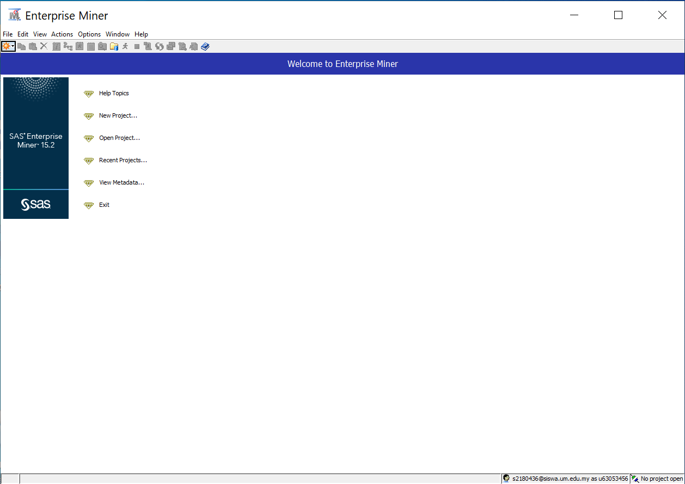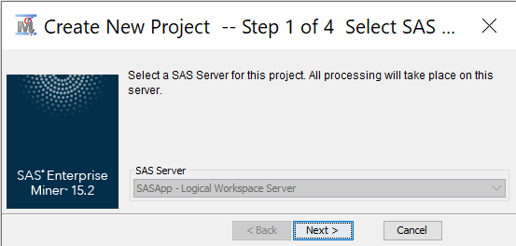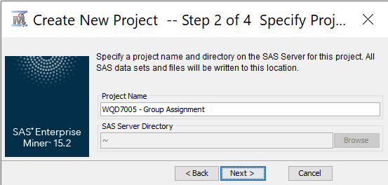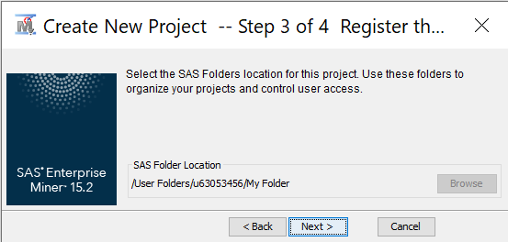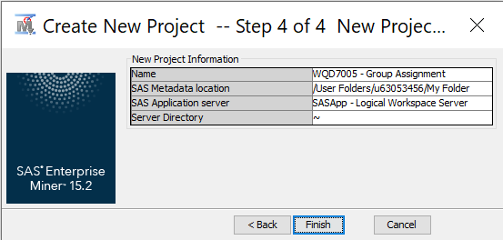

1. Create a diagram

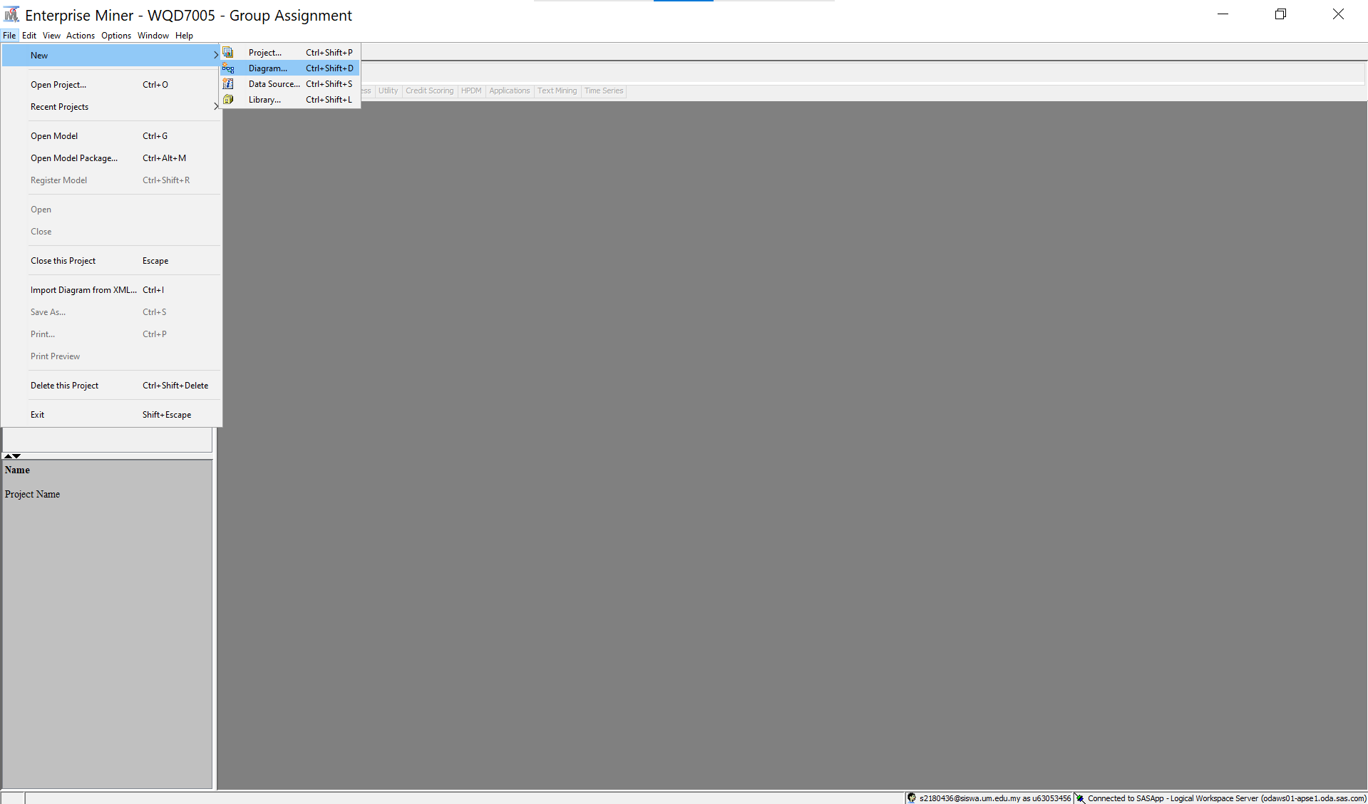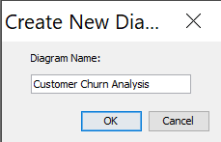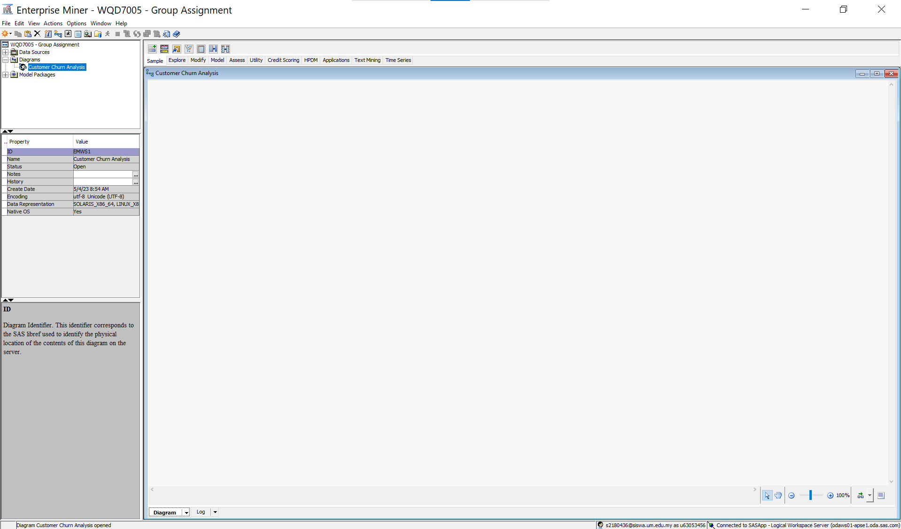

1. Import data as file and save as SAS file

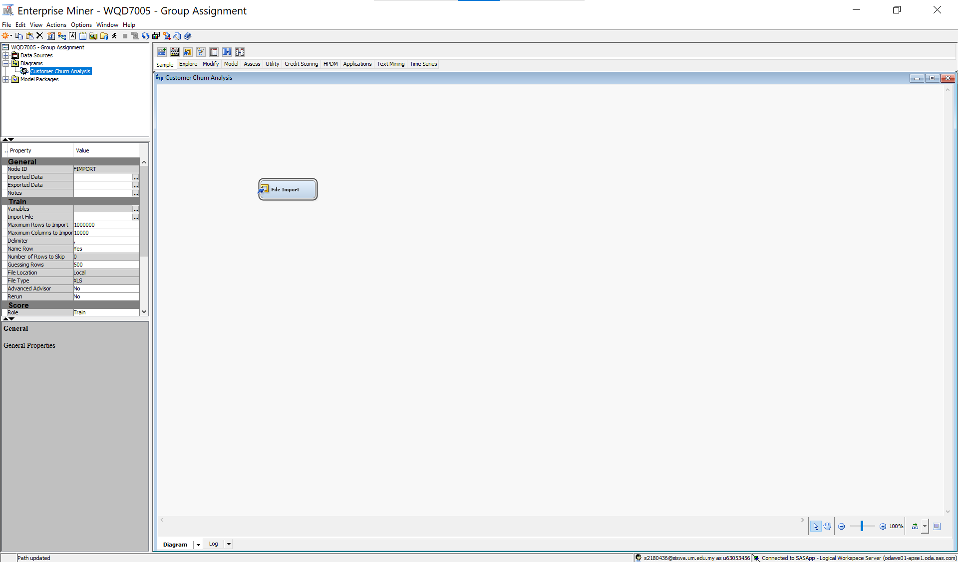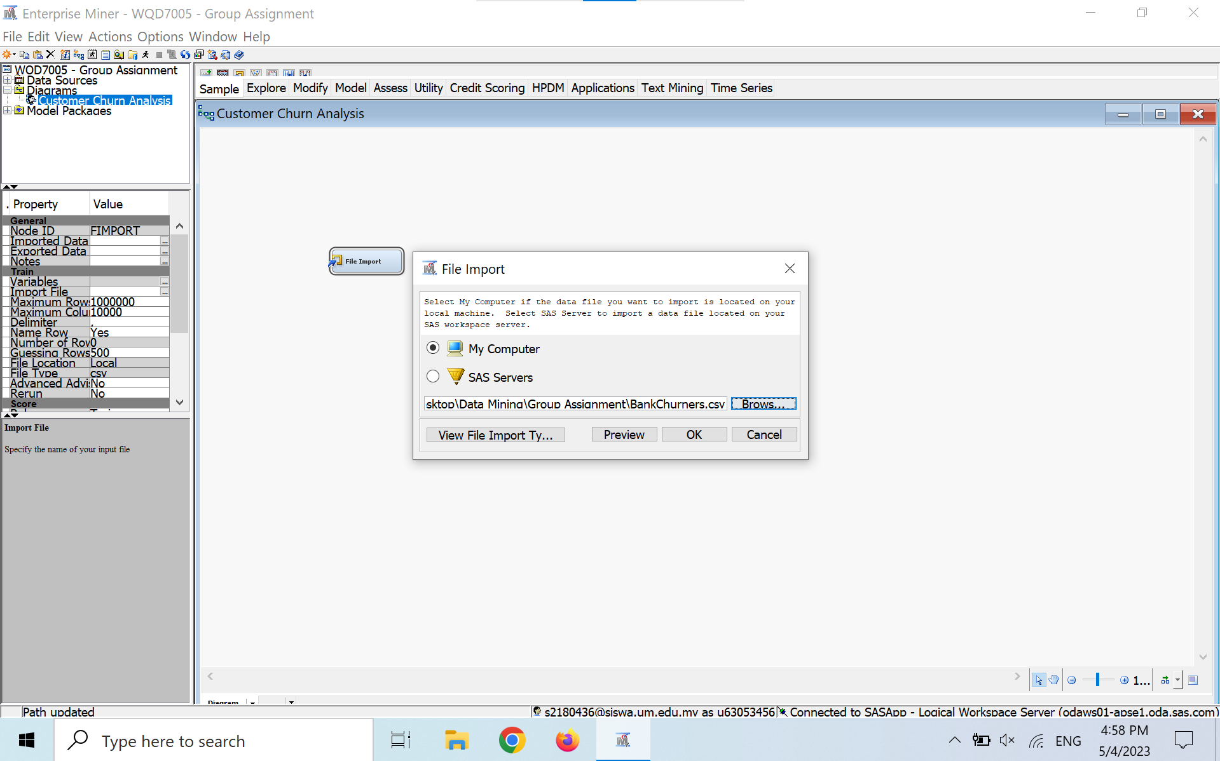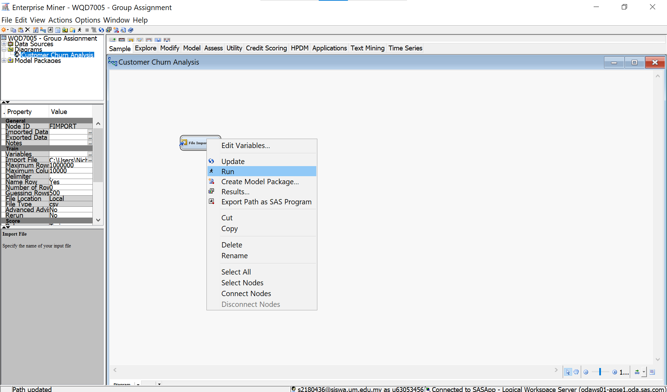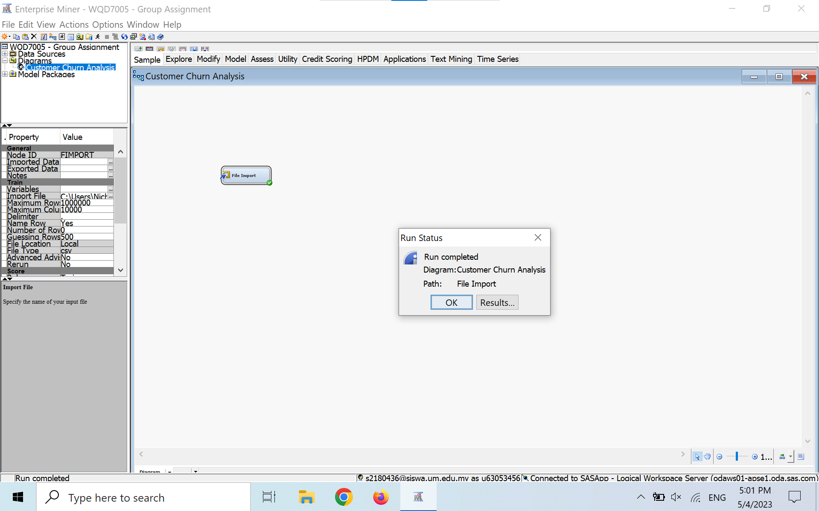

1. Create a library for the imported data SAS file

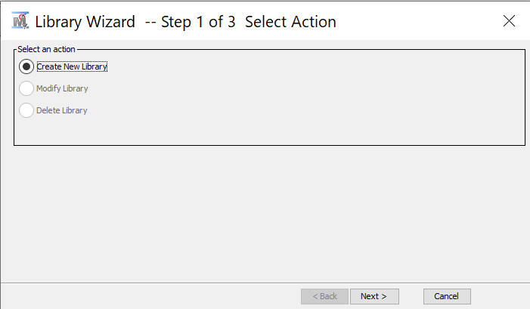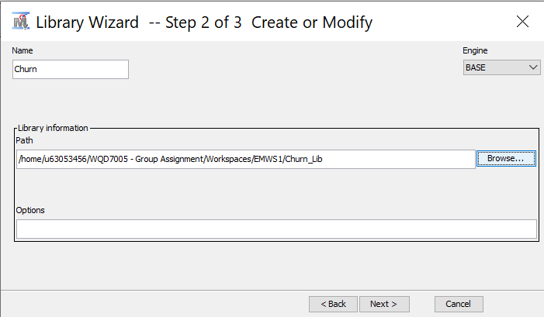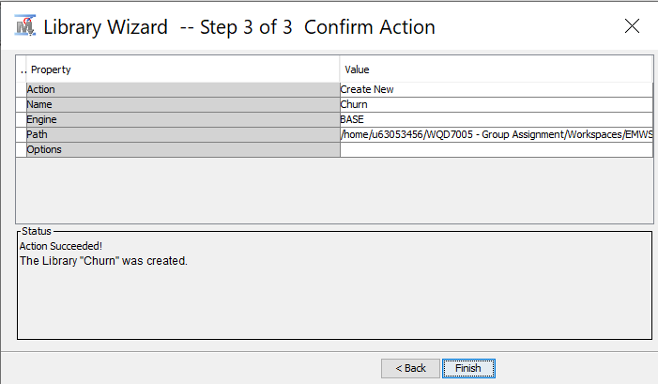

1. Create data source and extract the imported SAS file

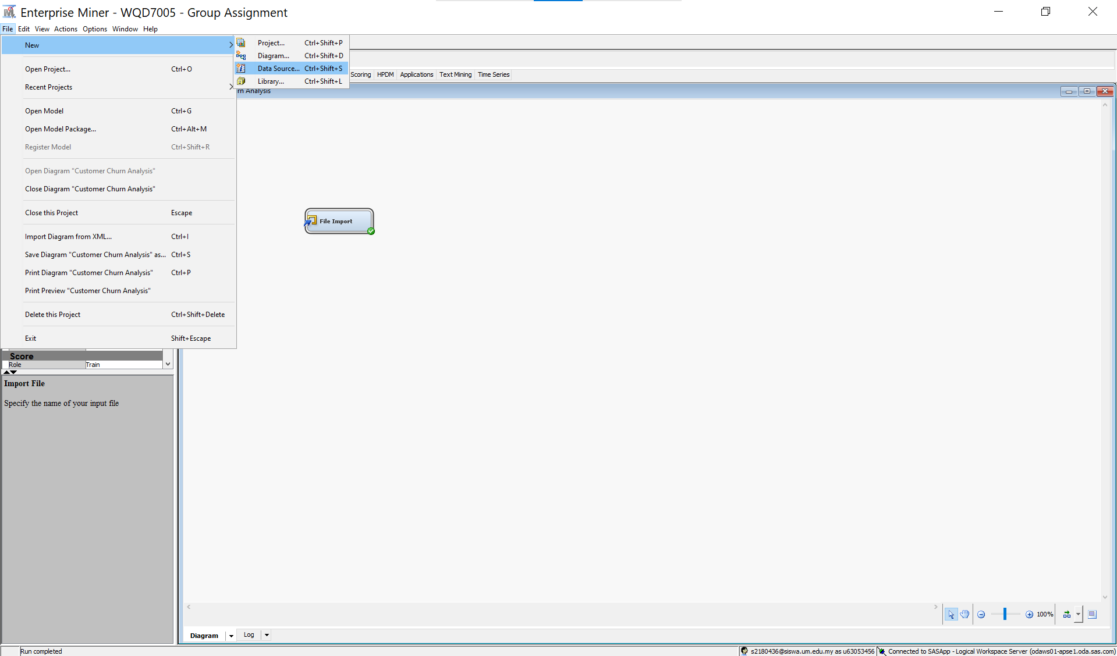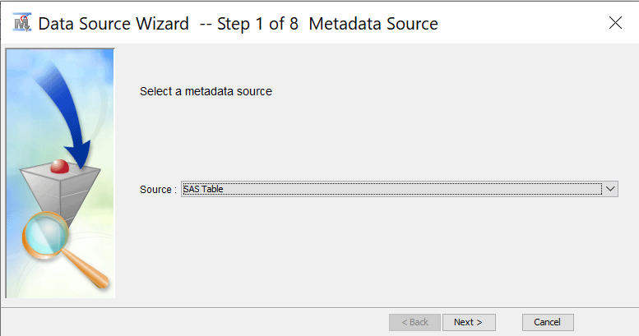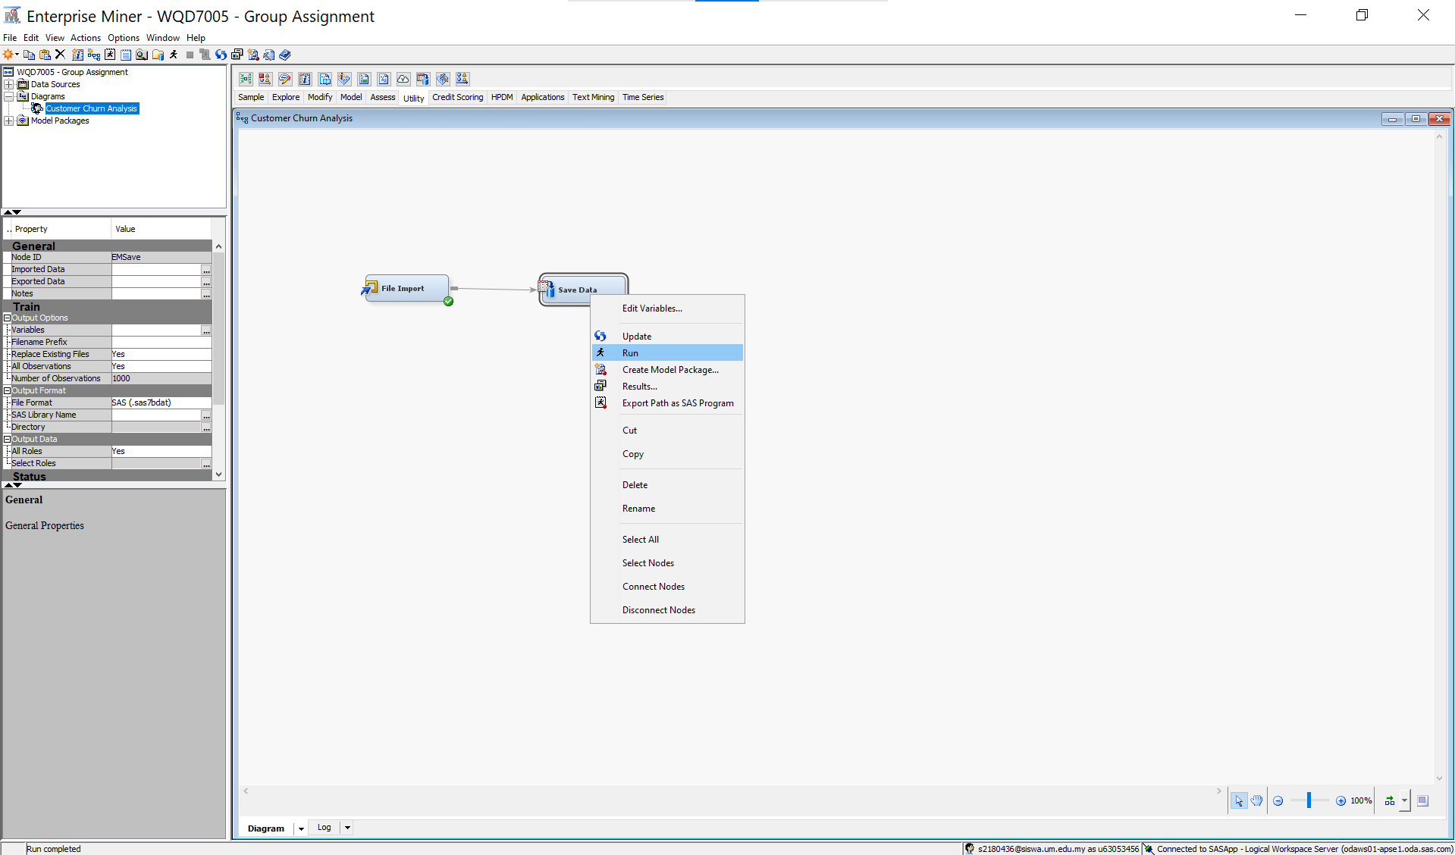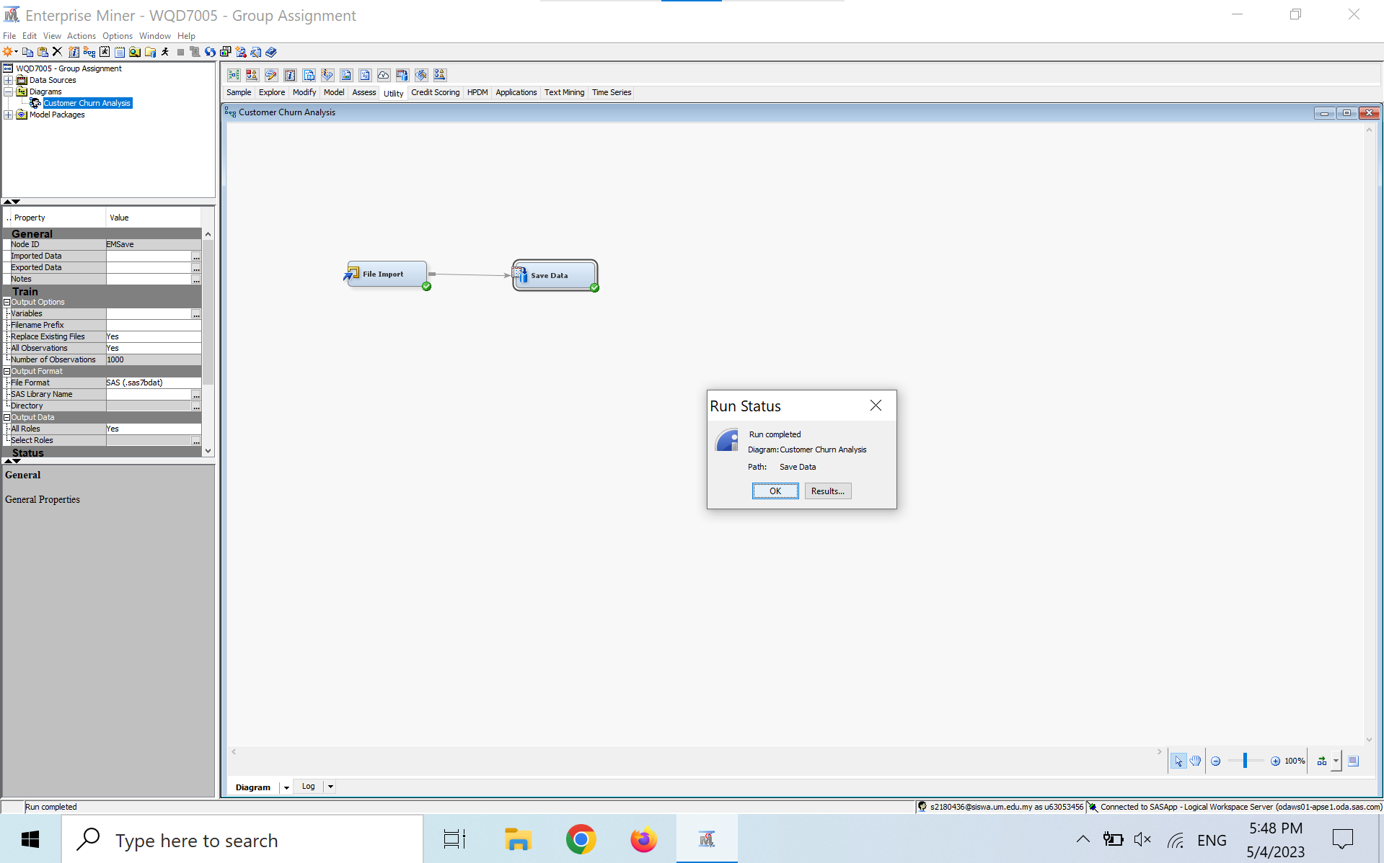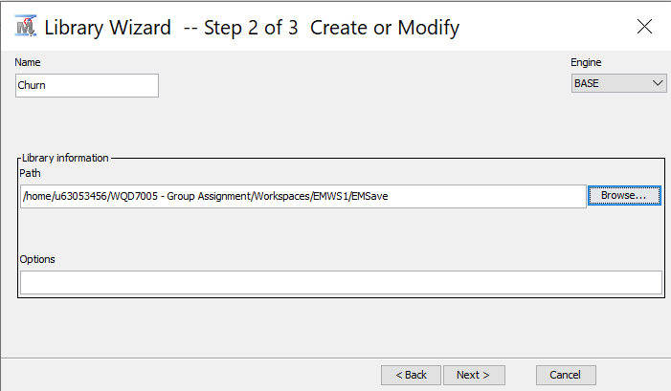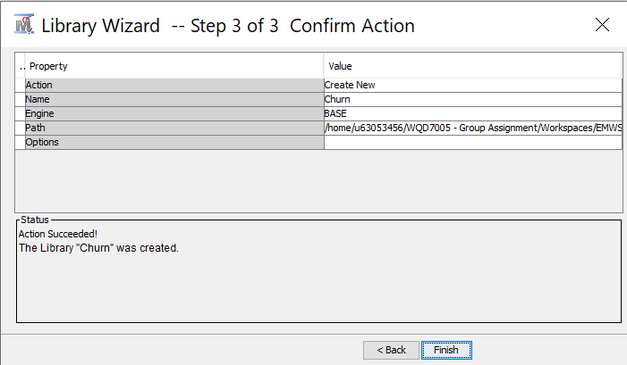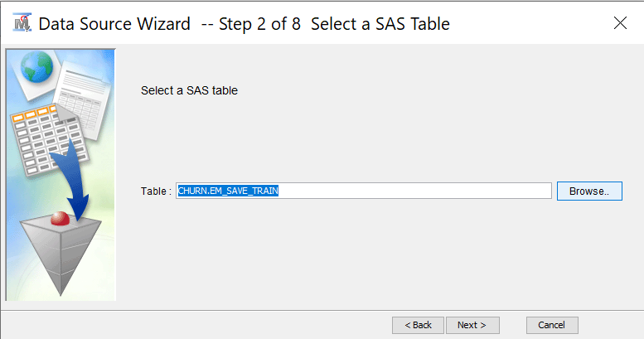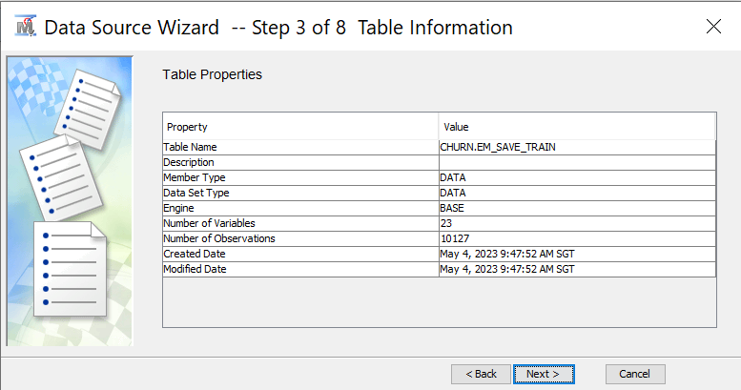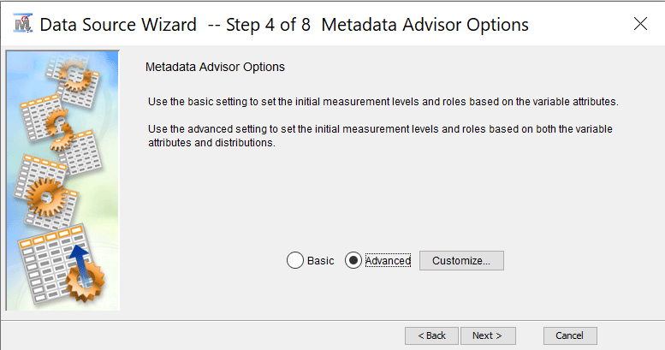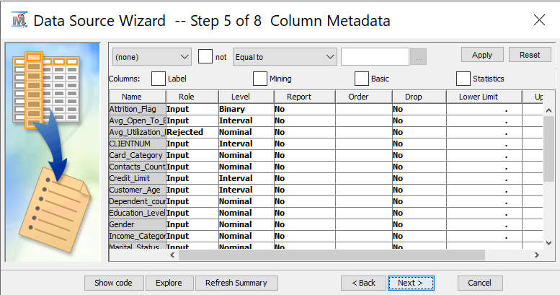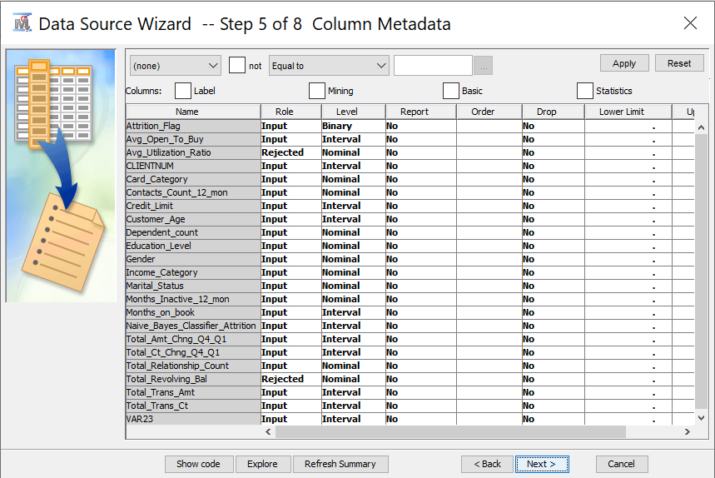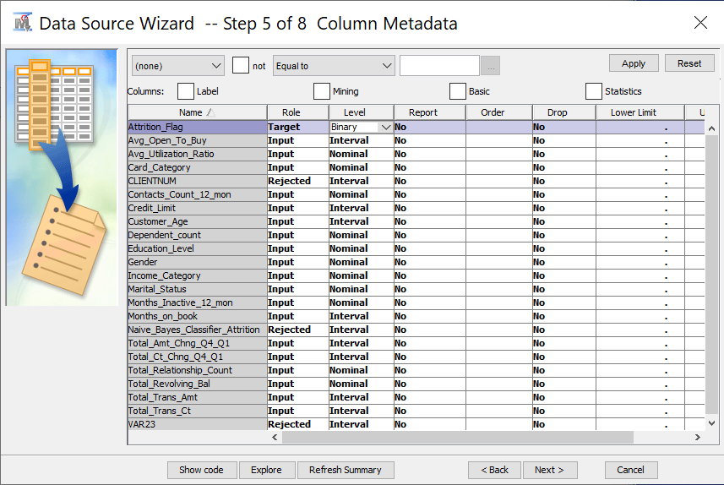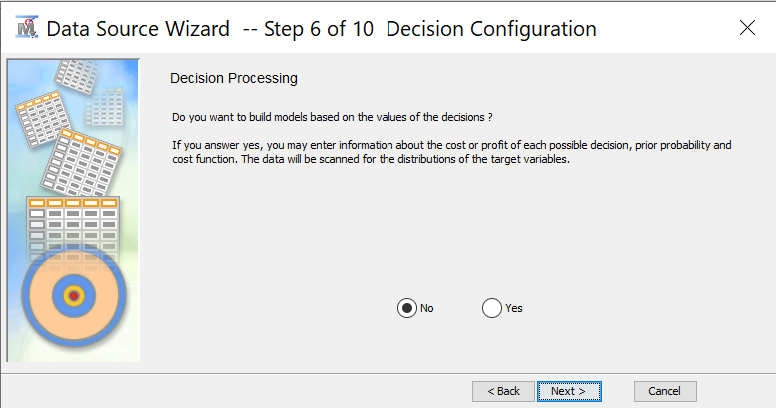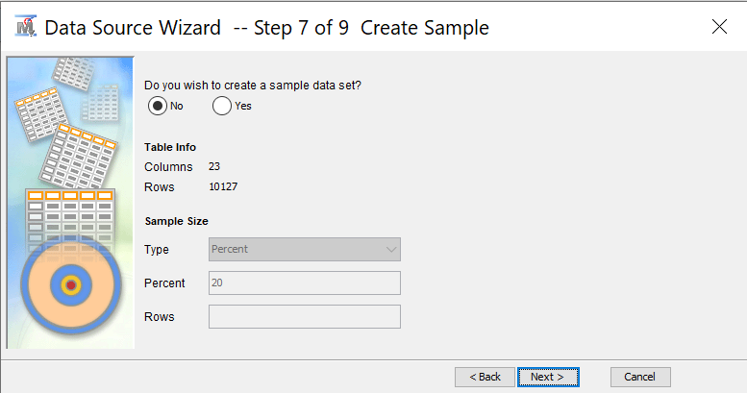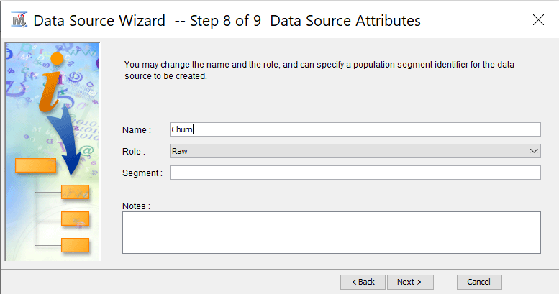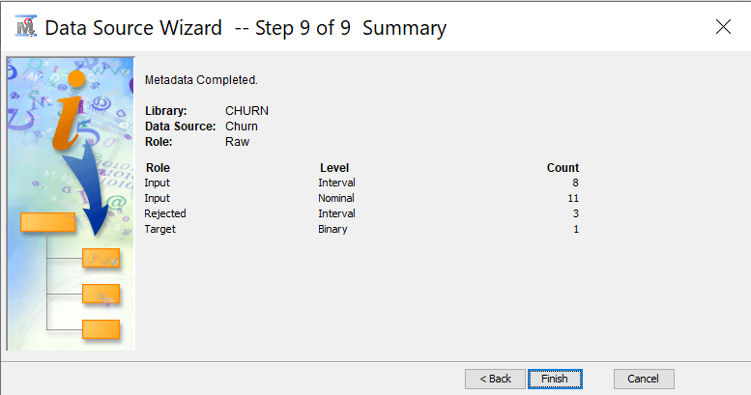

## 5.2 Explore

1. Generate statistics table

* In the explore page pull out the StatExplore.
* Right click then select run after success it will display the statistics table

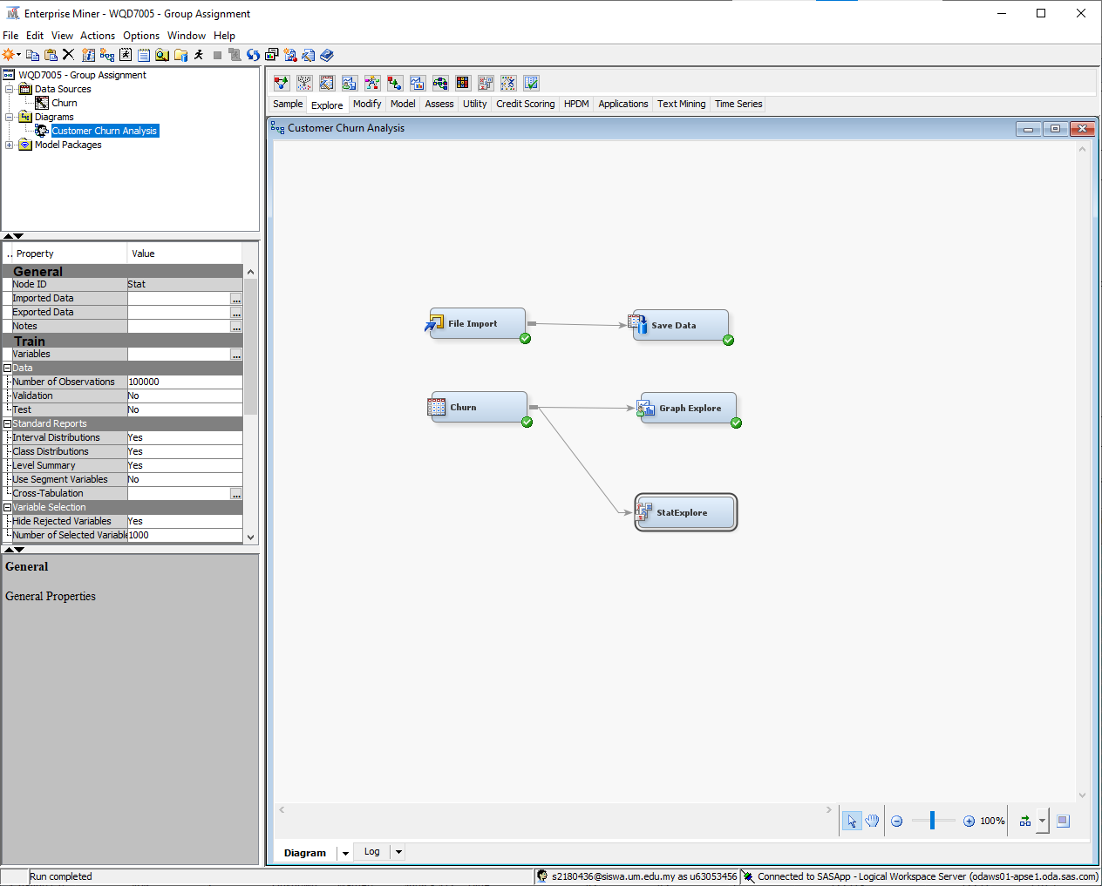

1. Select Graphs

* Same as the above figure in the explore part select graph explore and link with the churn datasets and right click run.

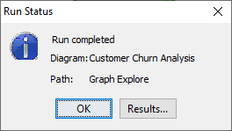

* After getting this run status you need click results… It means your visualization of the graph is prepared.

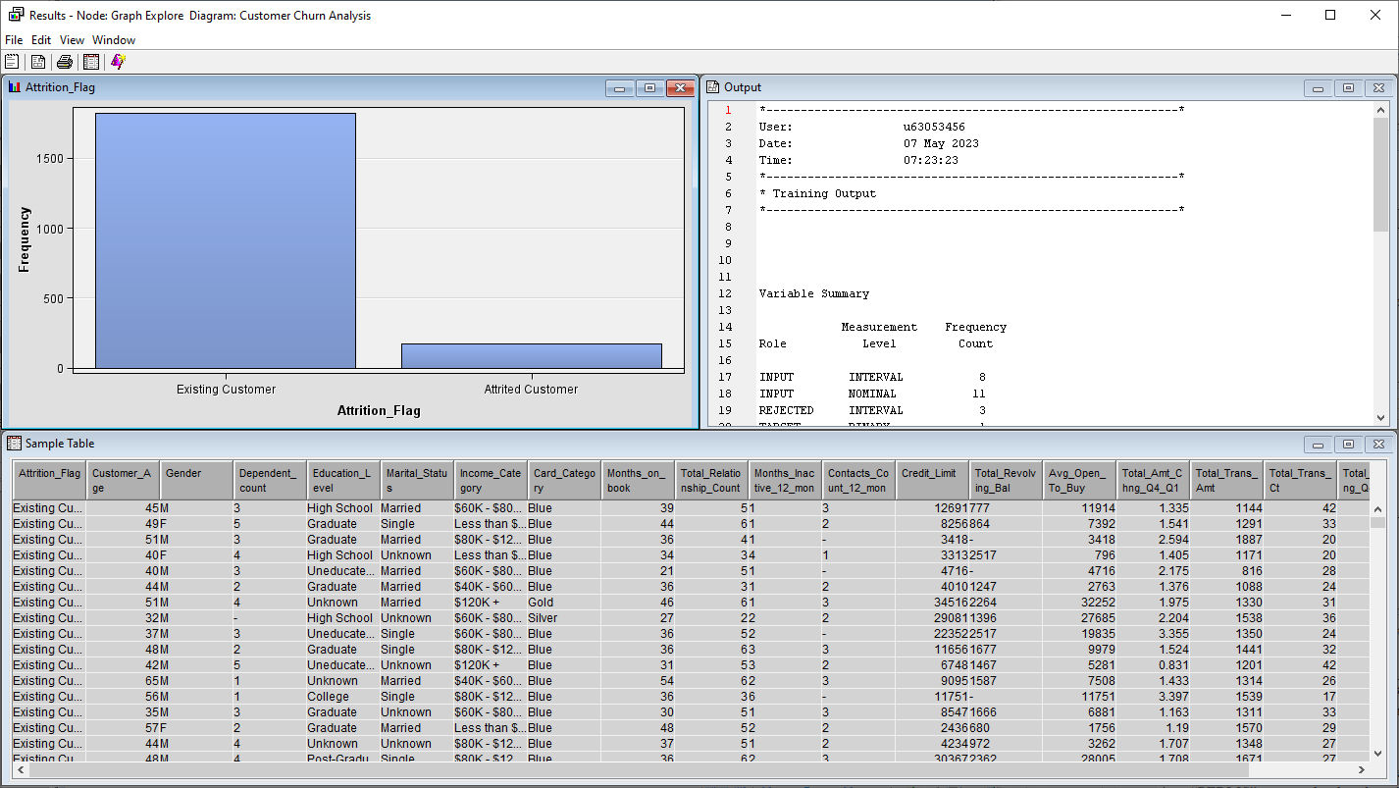

* This is the output after we clicked the results… . Next we need to explore the other graph. We need to click the icon in the top-left. There are 5 icons there. I need to select the last one which is the plot icon.

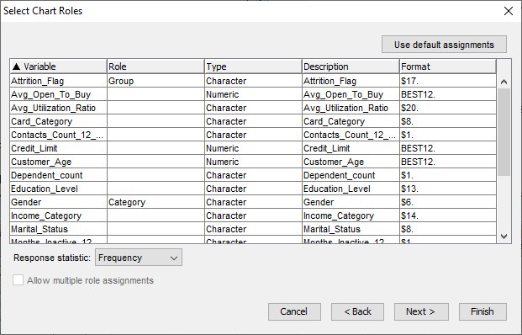

* Here we can specify the variable needed to assign in which role.

1. Add missing bin into the histogram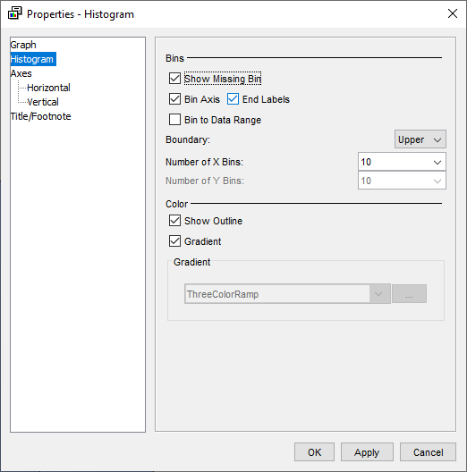

* Right click the graph and select graph properties. After that, got one box to select need to show missing bin or not.

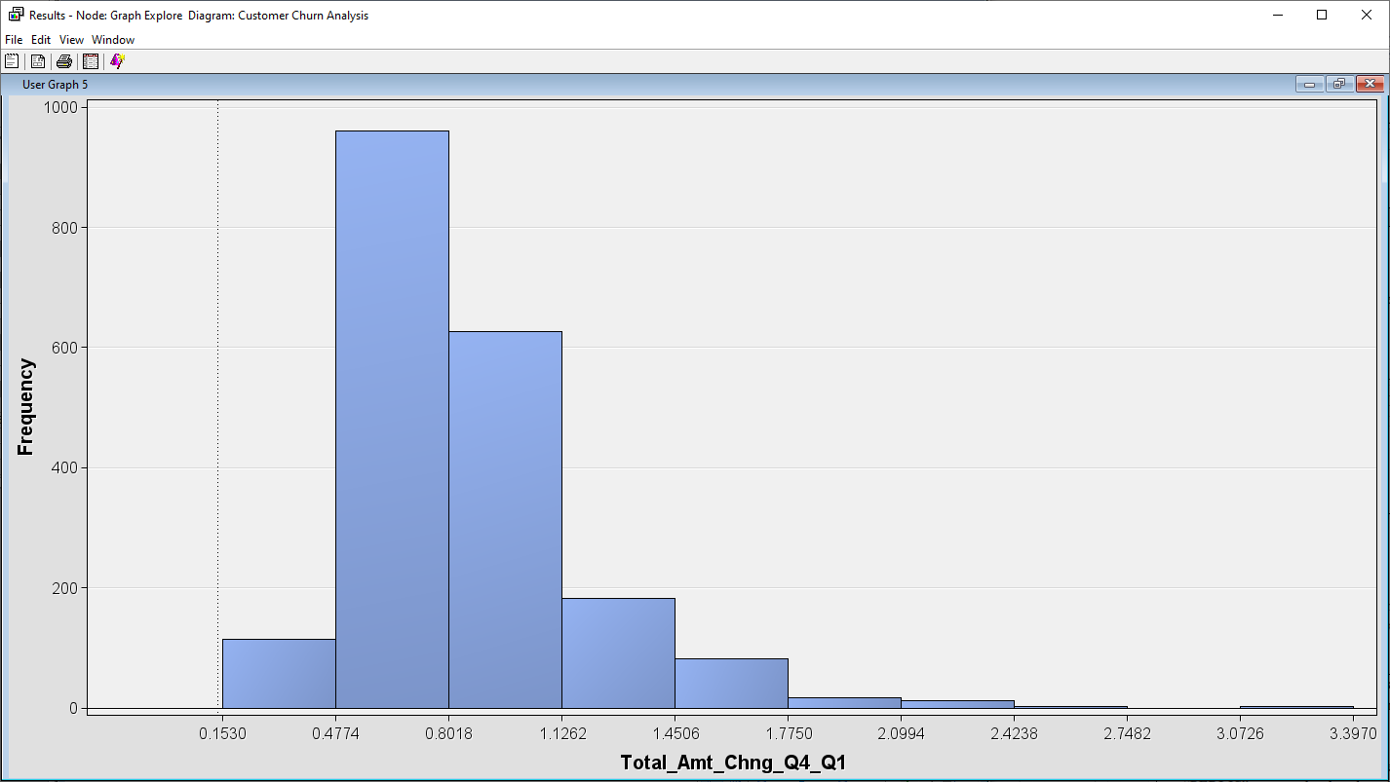

* Here are the results after showing the missing bin.

1. To obtain correlation matrix, StatExplore node is used.



* Select Cramer’s V to show the Cramer’s V chart.

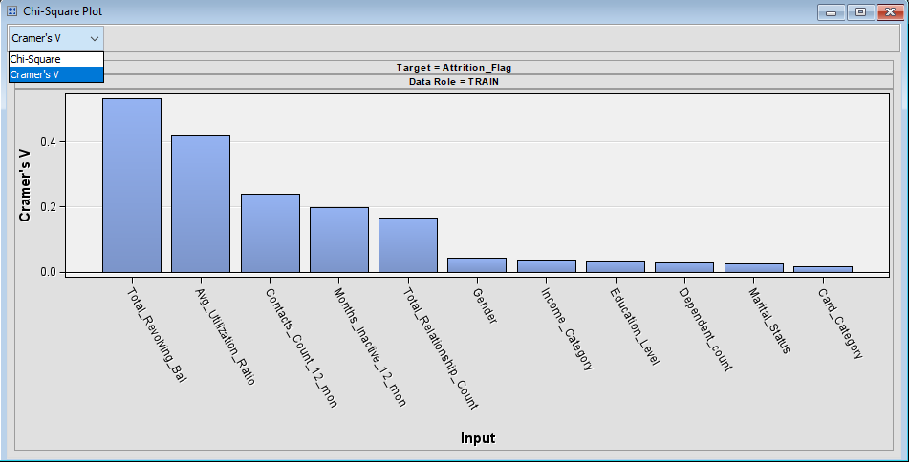

1. To obtain the correlation matrix, Variable Clustering node is used.

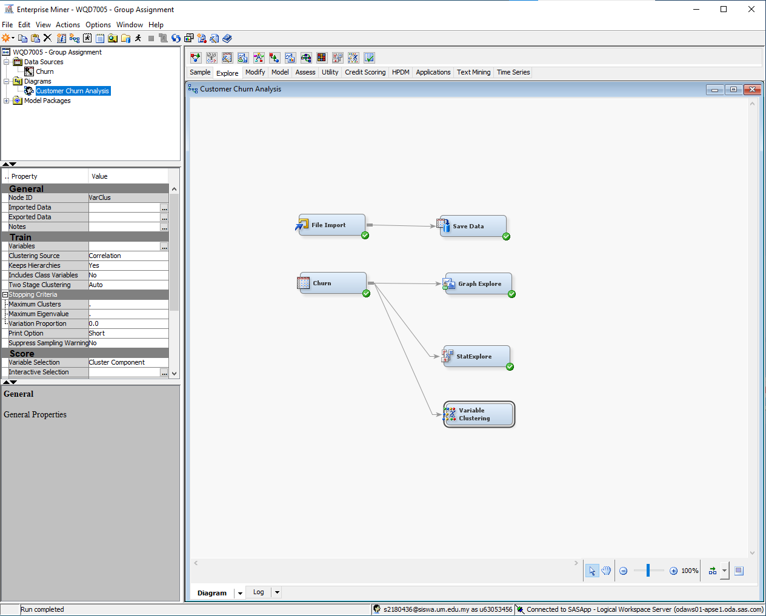

* Select View -> Model -> Variable Correlation to see the correlation matrix.

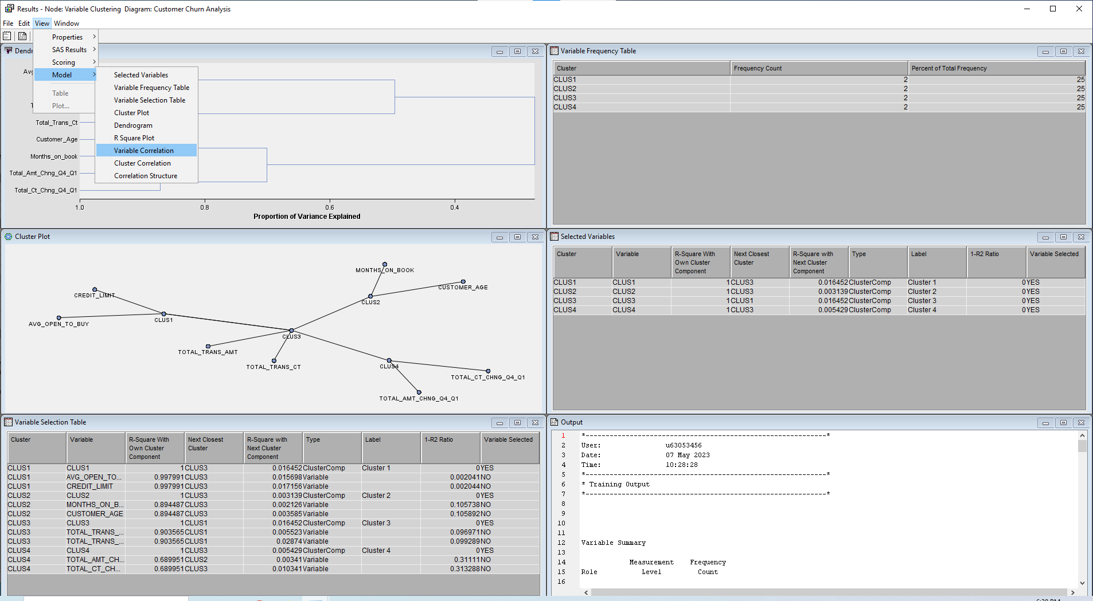

## 5.3 Modify

### 5.3.1 Modify Dataset in Talend

* Open Talend and import csv dataset
* Remove all inconsistent , Noisy and missing value.

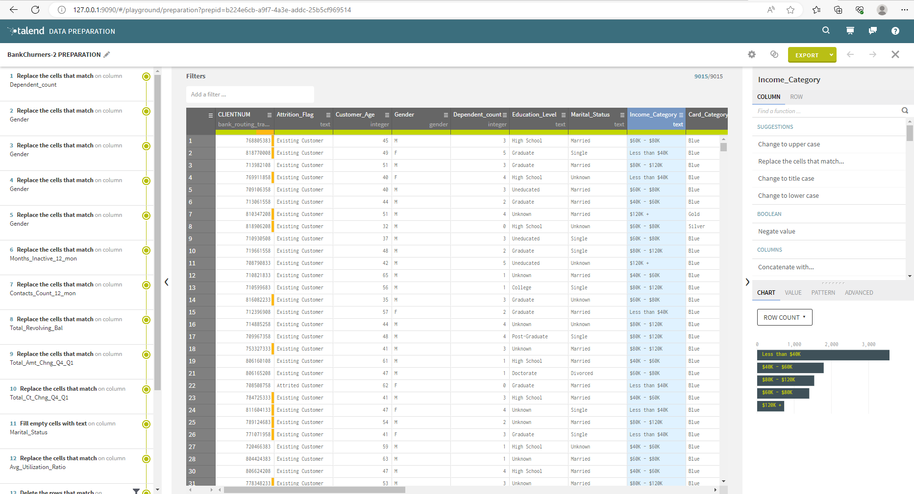

### 5.3.2 Modify Dataset in SAS Miner

* Transform the require column in SAS miner

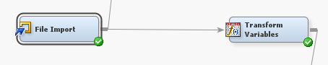

* Select Transform variables -> Train -> Variables -> Method -> Log 10

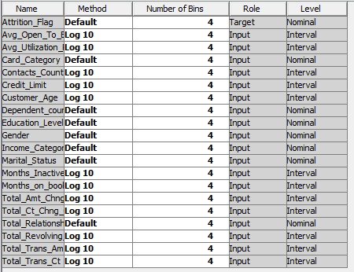

### 5.3.3 Data Partition

* Add Data Partition Node to Split Training Data and Validation Data

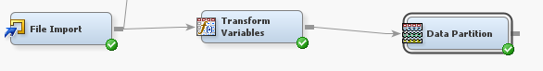

* Under Data Set Allocations, set 50% for Training and 50% for Validation

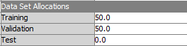

## 5.4 Model

### 5.4.1 Decision Tree Predictive Model

* Add and connect the partitioned dataset into the decision tree node.

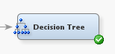

* The parameter used are as follows:

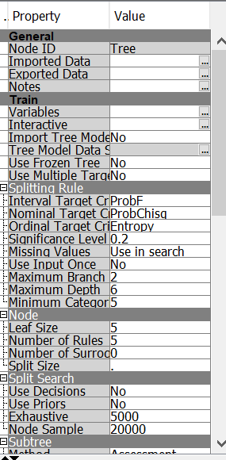

* The output of the decision tree are as follows:

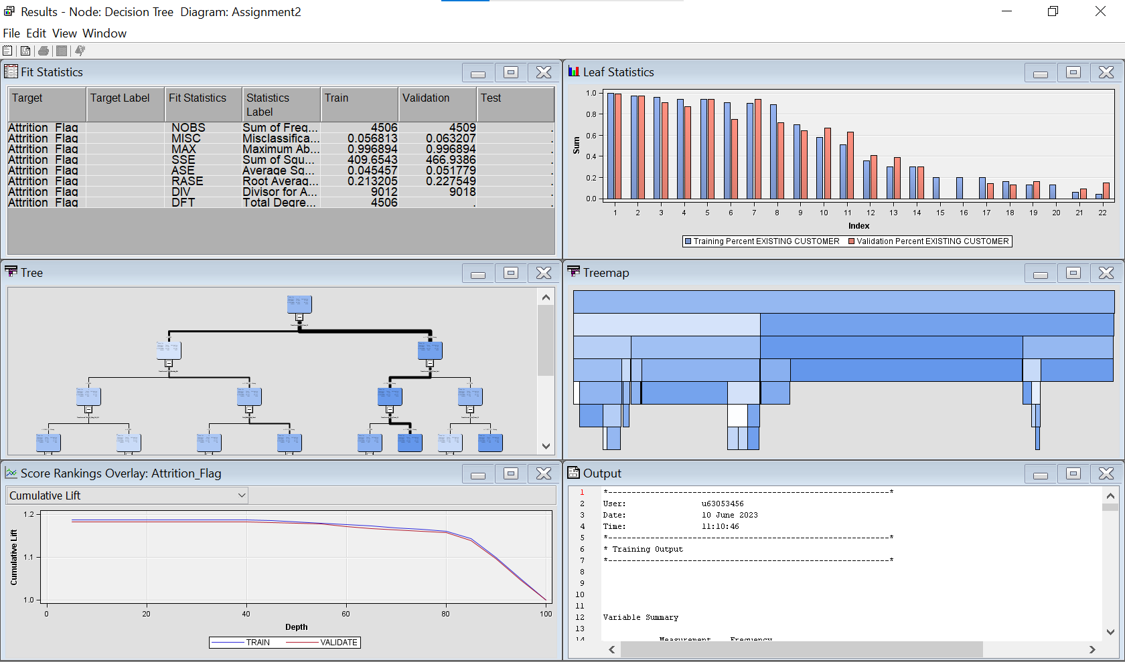

### 5.4.2 Gradient Boosting Predictive Model

* Add and connect the partitioned dataset into the gradient boosting node.

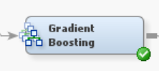

* The parameter used are as follows:

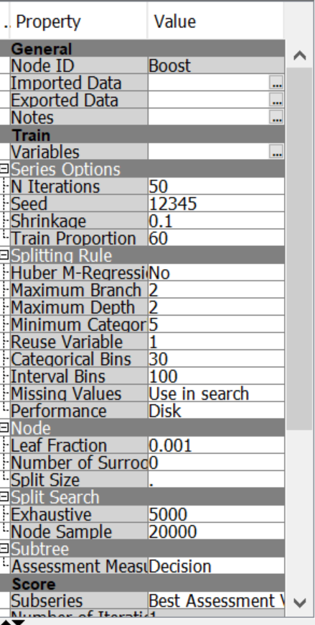

* The output of the gradient boosting result are as follows:

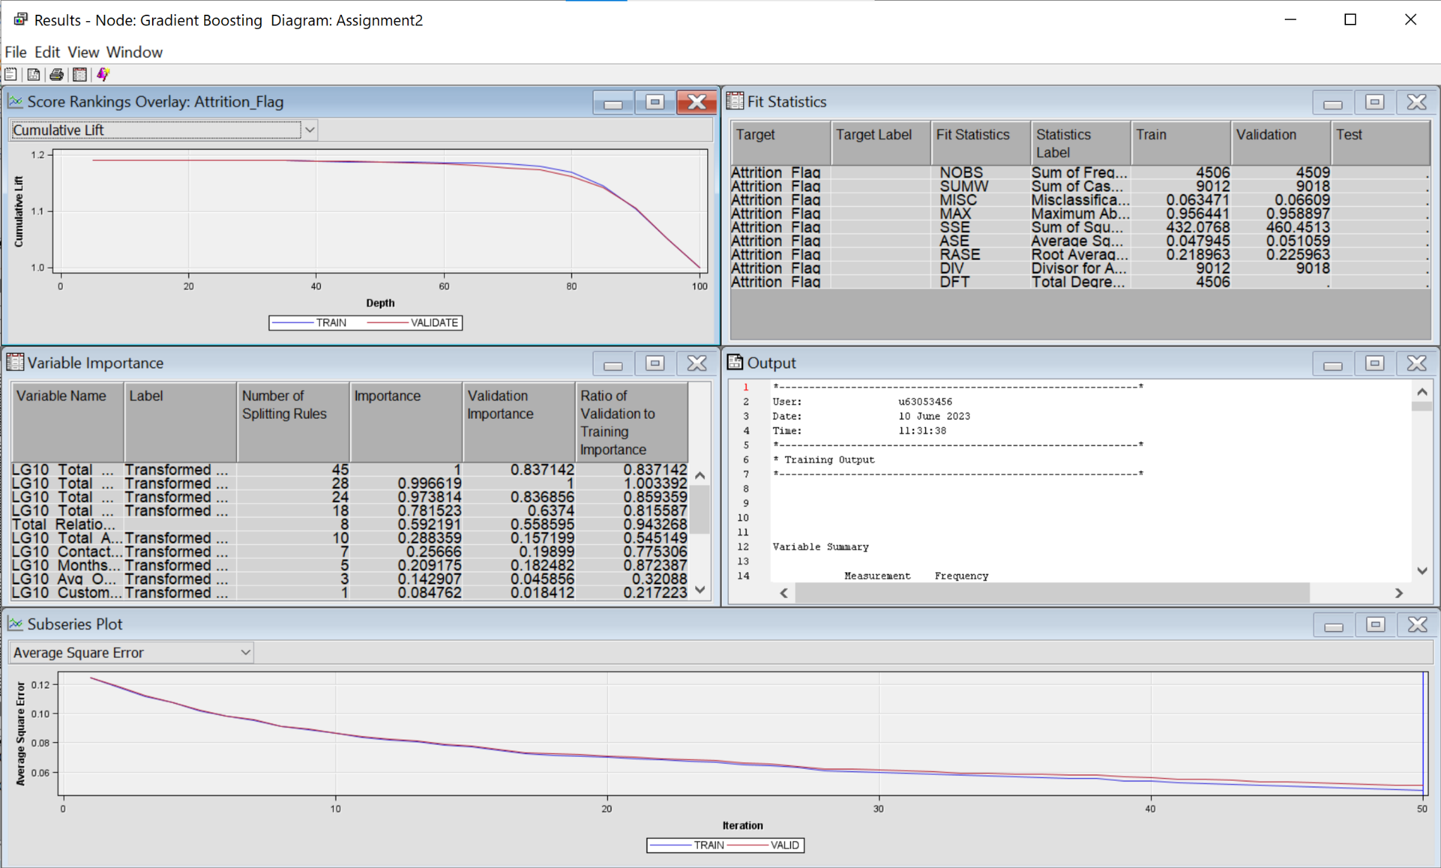

### 5.4.3 Logistic Regression Predictive Model

* Add and connect the partitioned dataset into the regression node.

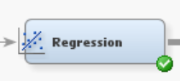

* The parameter used are as follows:

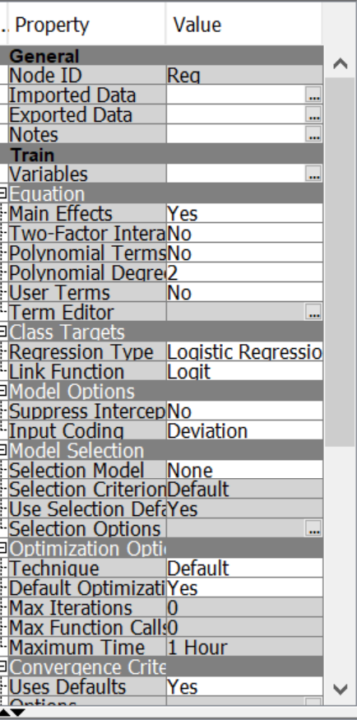

* The output of the gradient boosting result are as follows:

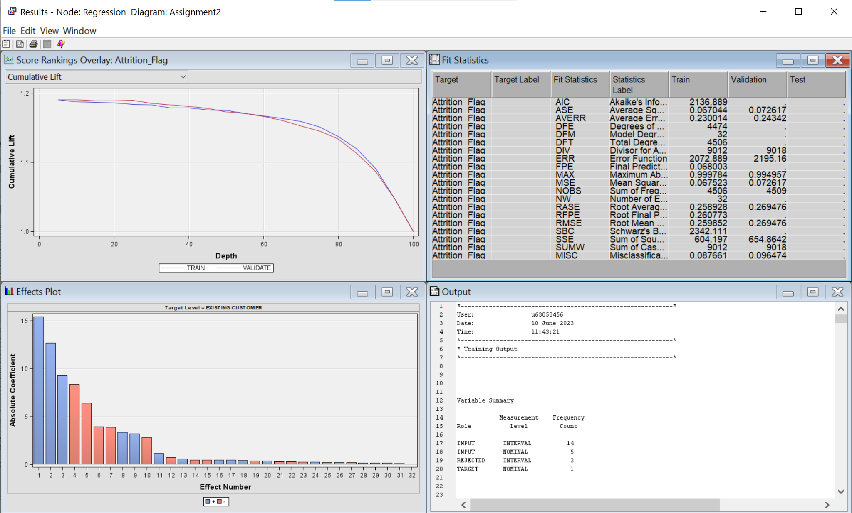

### 5.4.4 Neural Network Predictive Model

* Add and connect the partitioned dataset into the neural network node.

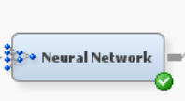

* The parameter used are as follows:

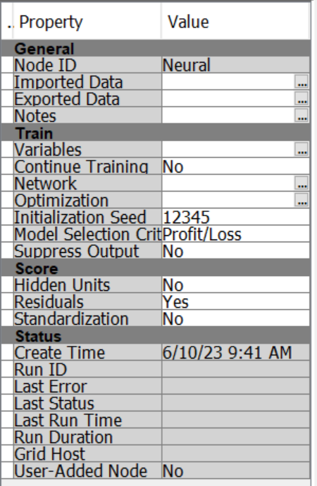

* The output of the gradient boosting result are as follows:

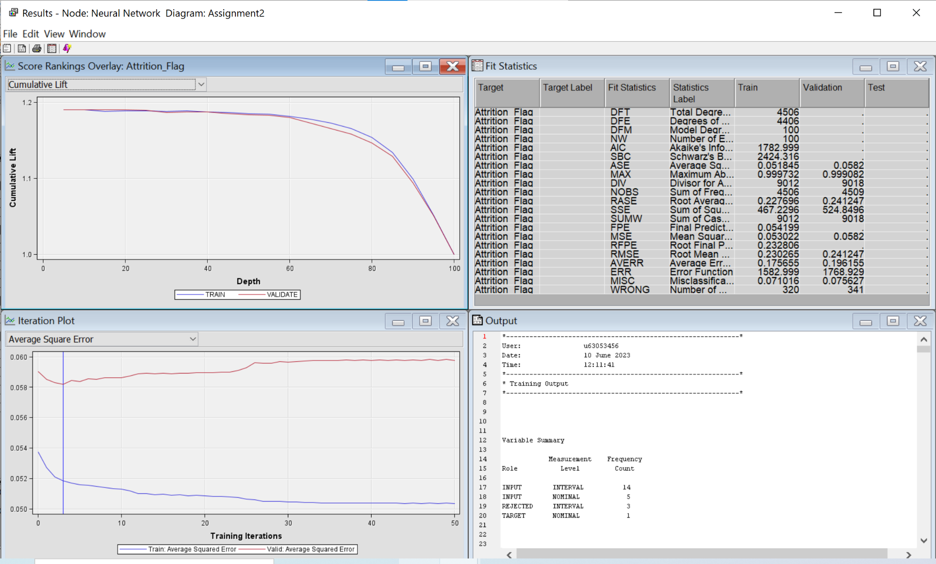

## 5.5 Assess

* Connect all four models into the model comparison model.

